BBC Live Lessons
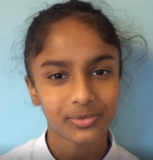
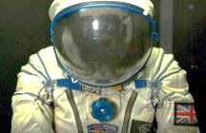
The BBC run live lessons for pupils on their online platforms. Recently Morland have been starting to get involved. First Sheriff and Amber asked Chris Packham a question and now we are delighted that Sasha in year 5 has asked a question to Helen Sharman as part of Science Week. If you are old enough you will remember Helen Sharman being the first British astronaut. Follow this link to see the lesson. Sasha’s question is at about 23 minutes. Good luck with being an astronaut, Sasha!
https://www.bbc.co.uk/teach/live-lessons/british-science-week-forces-live-lesson/z93wmbk
https://www.bbc.co.uk/teach/live-lessons/big-schools-winterwatch-2023-live-lesson/z6yb9ty
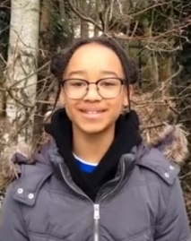
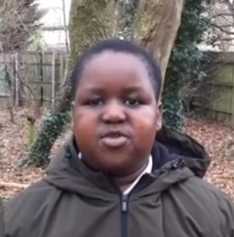
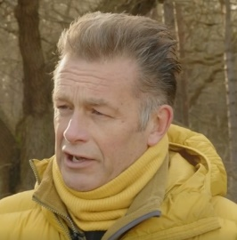

Planting Pants
Year 3 have enjoyed a visit from Dr Lizzie Sagoo and James Dowing. They are soil scientists. They told year 3 about the different types of soil and why soil is important. They discovered all life on earth depends on soil. All our food comes either directly from soil, like tomatoes, or indirectly, like cheese.
Year 3 explored different types of soil. They felt them and talked about how gritty they were and if we could make them into a ball. The different soils were sandy, peat and clay.
Then year 3 went out into the field and planted some pants! Year 3 want to see if the pants will be eaten by the different creatures that live in the soil. Year 3 planted the pants at different depths to see what will happen.
