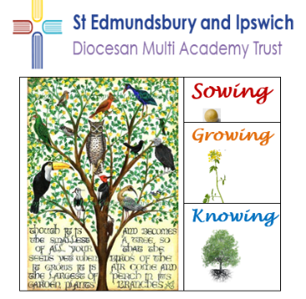

Bedfield Church of England Primary School
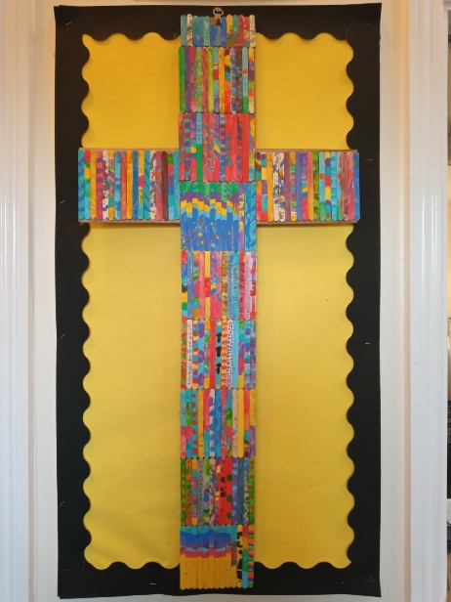
Spring term is all about seeing our school vision come to life. We made birds to fill the branches of our Mustard Seed Tree, representing the growth of our knowledge and skills and our resilient approach to learning.
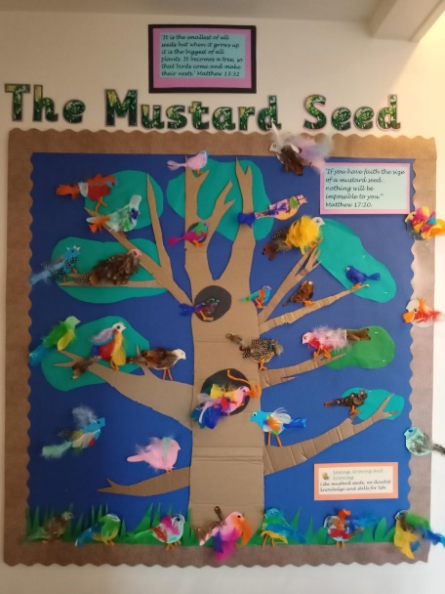
“If you have faith as small as a mustard seed, you can say to this mountain, 'Move from here to there,' and it will move. Nothing will be impossible for you.” Matthew 17:20-21. We made a cross from lolly pop sticks to show our unity as a school.
As a community, we voted for the Christian values that best represent our school. We chose:
Truthfulness, Compassion, Respect, Forgiveness, Friendship and Trust
We will be exploring the meaning of these values during our Vision Day when the children will be planting mustard seeds and pledging their aspirations for the future.

There have been changes at our school, which include swapping around classrooms. Our Early Years and KS1 writing area now looks like this…

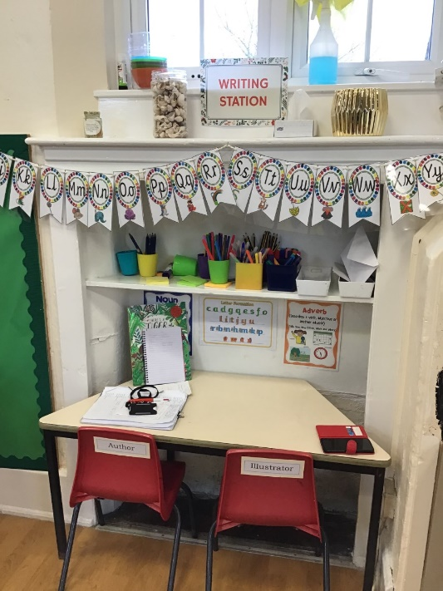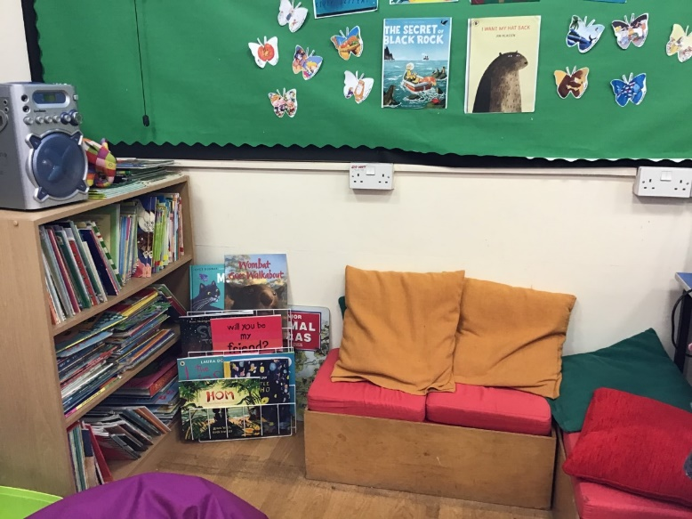
We are particularly proud to see some of the advancements our younger pupils have made in reading and writing.
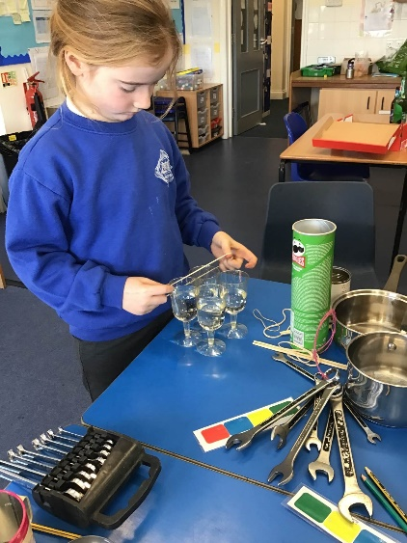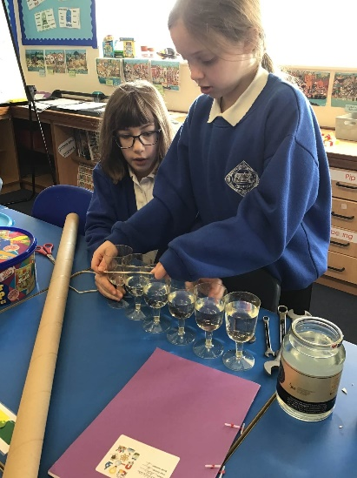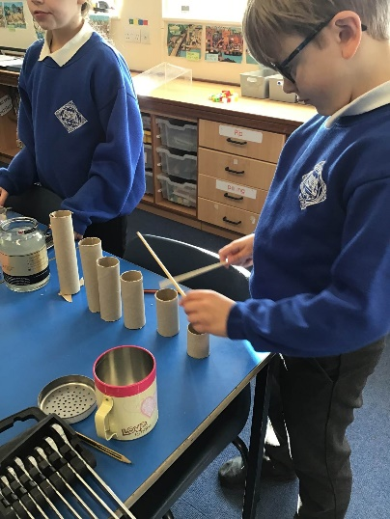
Some of the scientists among us have been experimenting with sound, finding different ways to alter sound waves and listening to the effects.

We all enjoyed an exciting day at Duxford Air Museum. The children followed this with writing for pleasure in different ways in their journals and can’t wait for Design Technology day when they will be designing and constructing their own planes.
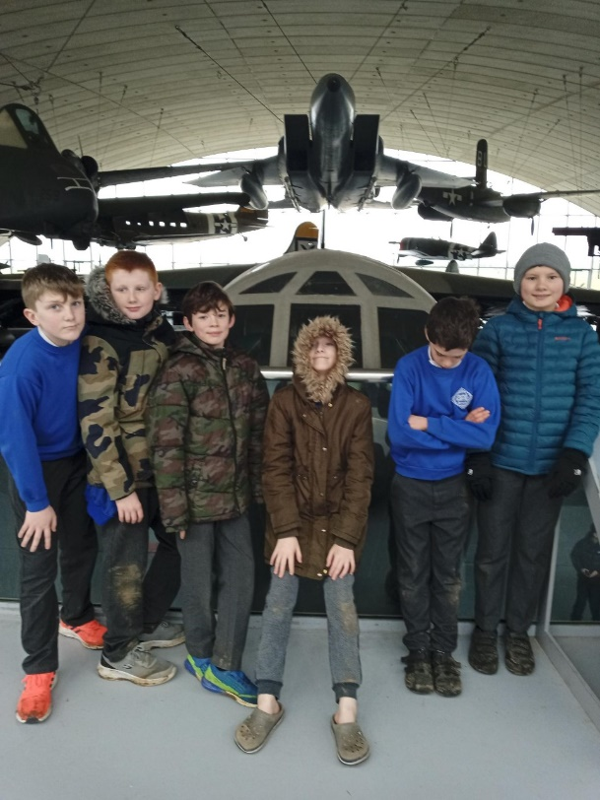
The Duxford visit also gave children an appreciation of the impact of War, reflecting on relatives who served in the second World War and continuing war in the world today.
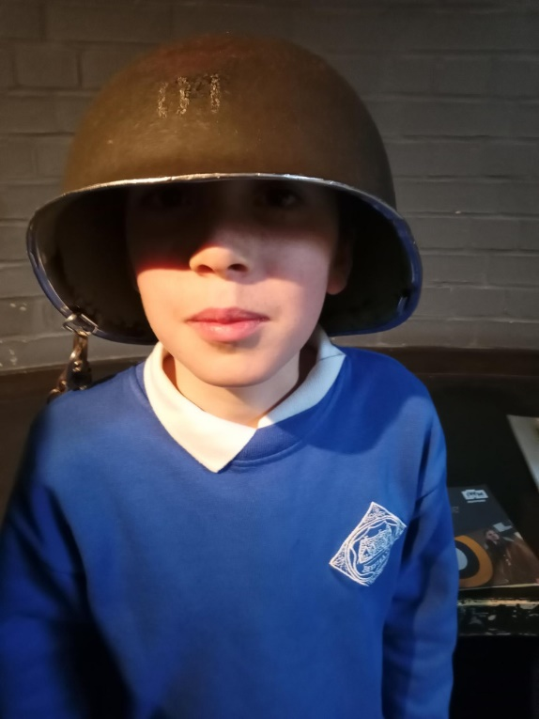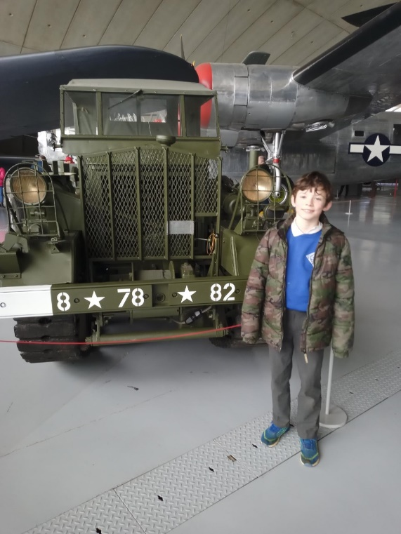

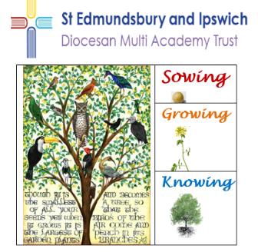

Wetheringsett Church of England Primary School
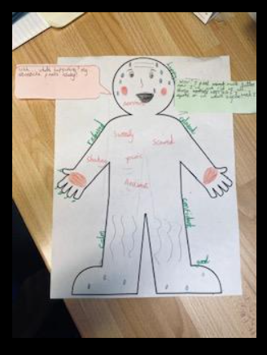

At Wetheringsett, the children studied online safety during Safer Internet Day. Sycamore Class illustrated how they felt when they were worried about an issue online and their feelings after telling an adult about it. This proved how important it is to share worries.

Lime Class made these amazing hand puppets during Design Technology Day. They showed how they could create individual designs, select materials and sew.
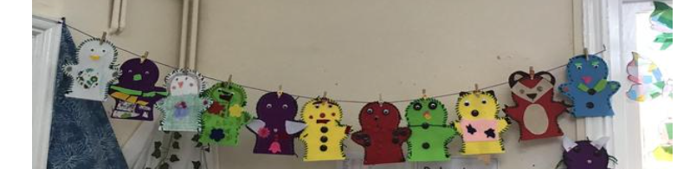
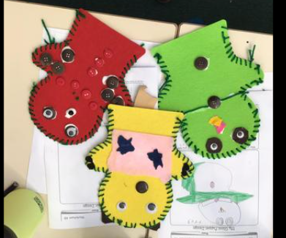
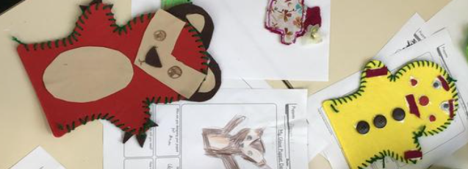

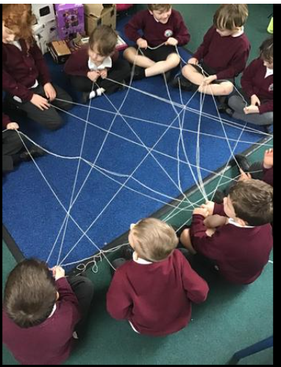
During World Thinking Day, Brownies and Girl Scouts came to school wearing their uniforms and explained some of the activities they have been doing to make a difference to the lives of others. All three classes took part in activities to think about diversity in the world.
