Bramfield CE School is 150 year old.
Bramfield Primary school first opened its doors in 1872. So it seemed appropriate to have a week of celebration combining our 150th birthday celebrations with the Queen’s Platinum Jubilee.
During the week we have time travelled through the last 150 years.
We started with an open invitation to any ex-pupils and staff to come back to Bramfield and tell current pupils some tales of their past. It was a fabulous afternoon bringing to together people from all generations who were keen to share their fond memories of time at Bramfield Primary School.
One of our eldest guest was Mr Burrows who attended the school in 1934 he is pictured below with our current youngest pupil in school. We ended the afternoon by singing happy birthday to the school.
Guests were able to look around a mini museum with logs books, photos and memories of past pupils and staff. Some of the guests brought their own photos to add to our collection of memorabilia
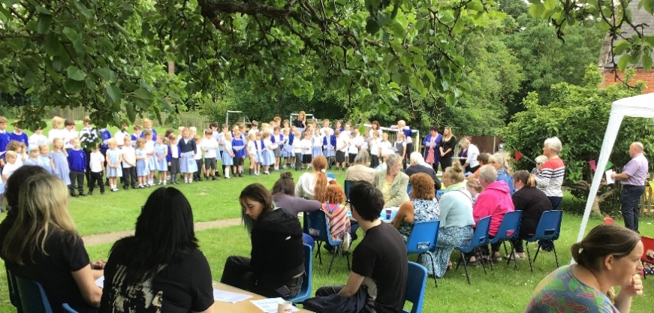
We learned that there used to be a boy’s playground and a girl’s playground, there were three air raid shelters in the grounds and that the two trees at the front of the school were used goal posts in years gone by.
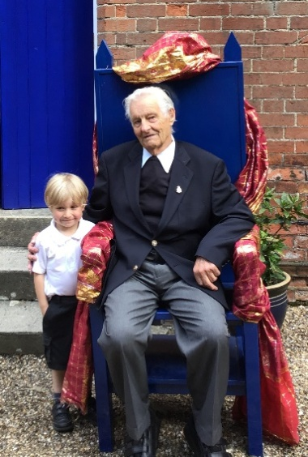

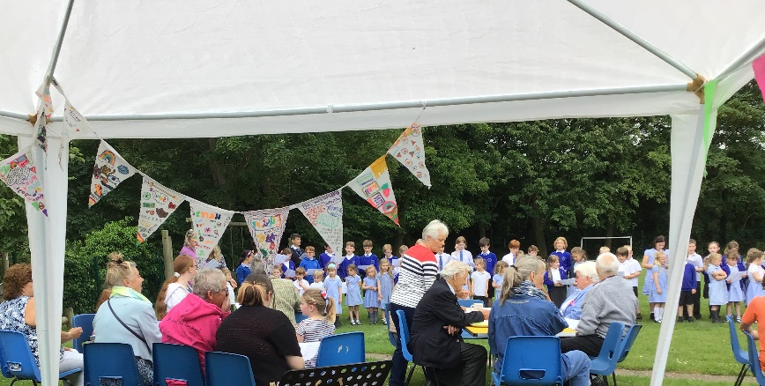

On Wednesday we travelled back in time to the Victorian era to experience what school would have been like for those children who first walked through the doors of Bramfield Primary School. Val came into school and led some very strict Victorian style lessons including reading from the bible, practising our handwriting and reciting the alphabet. Queen Victoria herself made an appearance with a birthday cake. By the end of the day we all agreed that we much preferred wearing our modern clothes
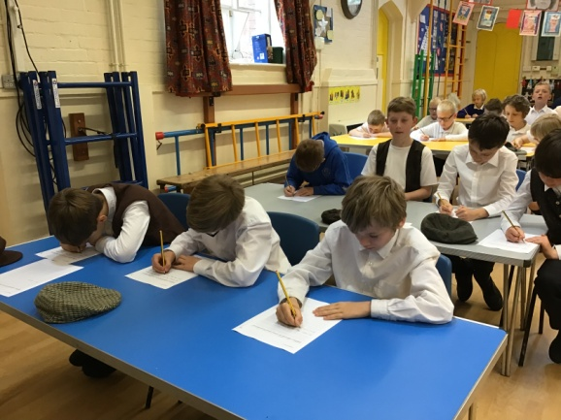
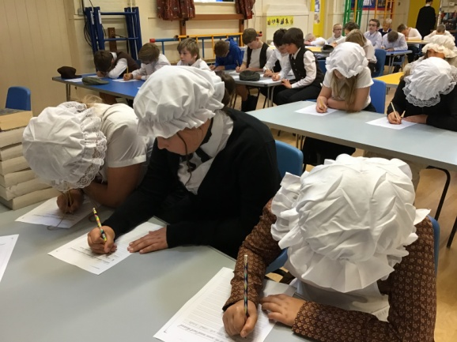

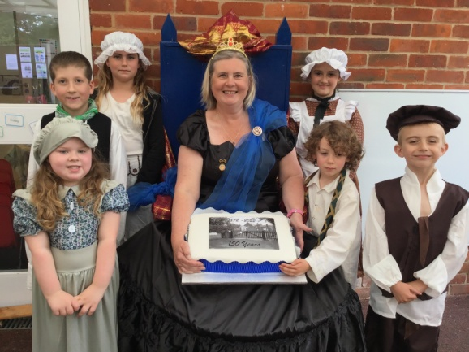

Thursday we spent the day learning about a decade of the Queen’s reign from the 1960s to the 1990s. Reverend Linda came and blessed the Jubilee trees for us. Helen, Suffolk Tree Warden helped us source the trees that had a special link with our class names. The trees were donated by the Sicon Foundation as part of their environmental projects.
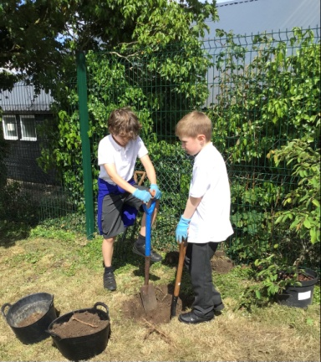
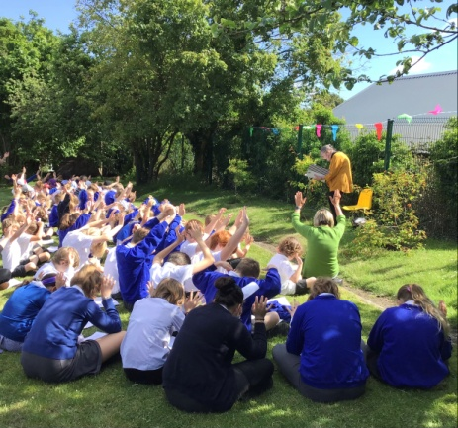

Friday was the culmination of our week of celebrating. In the afternoon parents and carers joined us for a jubilee street party. Children and parents worked together to solve a royal scavenger hunt, play some traditional games, visit the mini museum and paint pebbles for our river of hope.
We ended the week by singing the national anthem and cutting and of course eating a Jubilee cake.
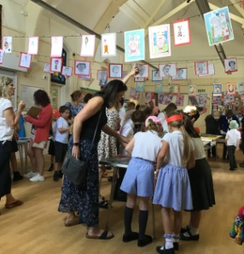
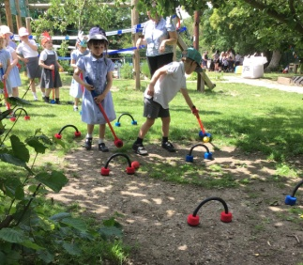
Lots of great memories have been made and captured to look back on perhaps at the 200th birthday celebrations!
