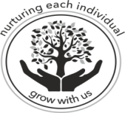**The Association of Bramfield, Brampton and Ringsfield Church of England Schools**

**Executive Headteacher: Mrs Victoria Allen**

**Head of Schools: Linda Ashford, Ali Thomas, Steven Jeal**

**Maths Across The Curriculum**

At Brampton CE Primary School we had a fantastic morning of Maths, focussed on ‘Maths across the Curriculum’.

**Reception**

The children in Reception enjoyed making their own Superheroes using 3d shapes, they selected the shapes they wanted and then counted how many of each they had.  The children had a go at writing down how many of each shapes they have used.

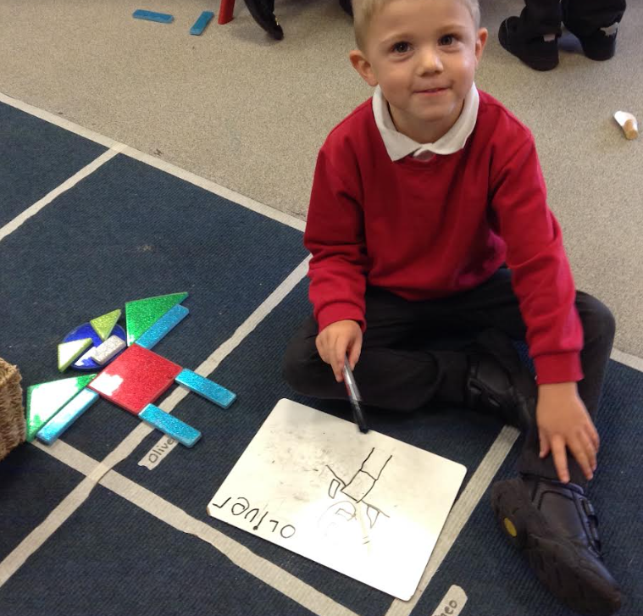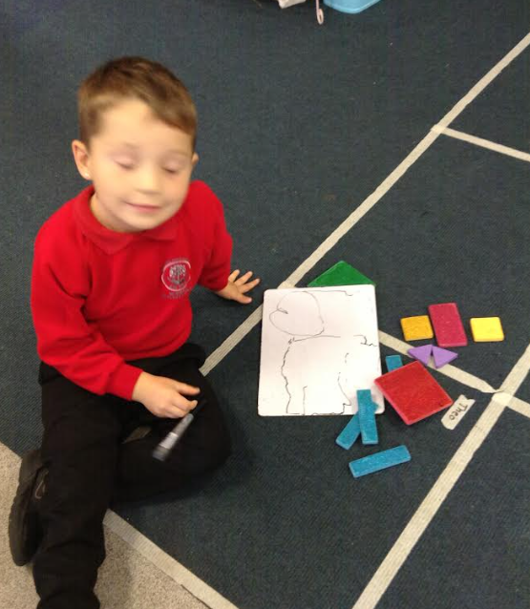

**Year 1-2**

KS1, made links between maths and art by using shapes to create some monsters. Whilst creating monsters, the children discussed what each shape was and how many sides and vertices they each have. Once the children had created their shapes, they looked at what a tally chart was and made a chart of which shapes we had used to see what the monster was made out of.

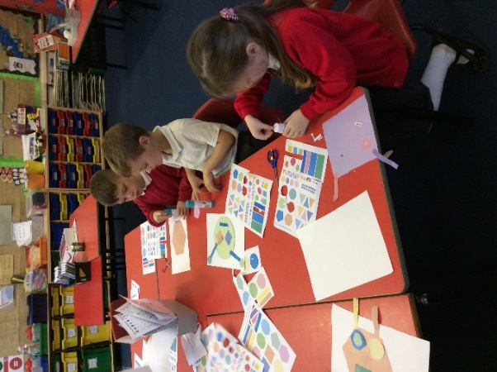 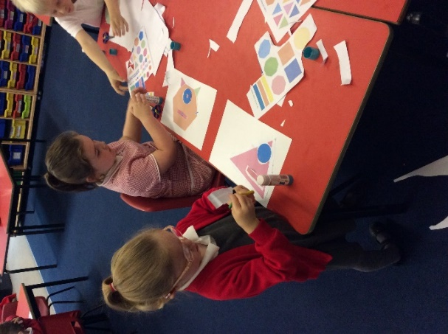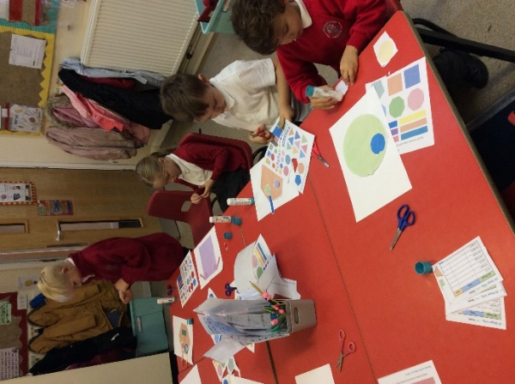

**Year 3/4**

Year 3/4 engaged with a morning of DT/Mathematics. The children enjoyed studying famous structures around the world. Whilst looking at the structures, the children discussed both 2D and 3D shapes, identifying their names and properties. The children were then given the task of designing their own skyscraper using only one piece of A4 paper. Once the children had completed their constructions they had to measure them accurately to see who had created the tallest tower- the winner was 58 centimetres! All the children enjoyed the practical application of Maths during this lesson.

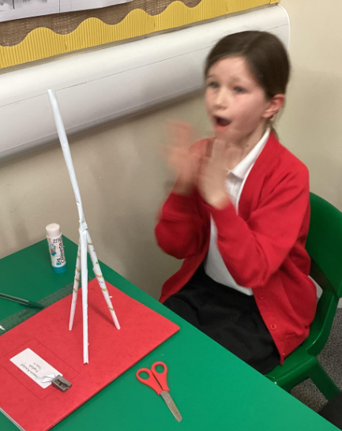 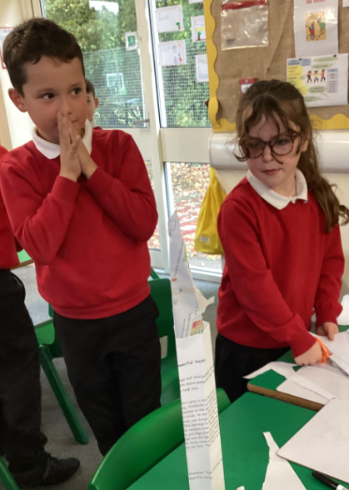 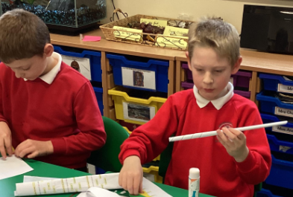 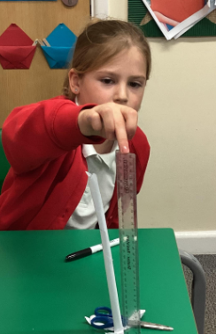

**Year 5/6**

The children visited Redgrave and Lopham Fen as part of their River project. As well as learning about a local geographical region the children were also given the opportunity to develop their Mathematical skills/knowledge. The children were measuring the size of the river at different points from the source and also measuring the depth of the river. When the children visited different locations they learnt how to find each location on a map using grid reference numbers. Applying mathematical skills to real life geographical field work helped children to understand the relevance of their learning and why Mathematics is a fundament skill.

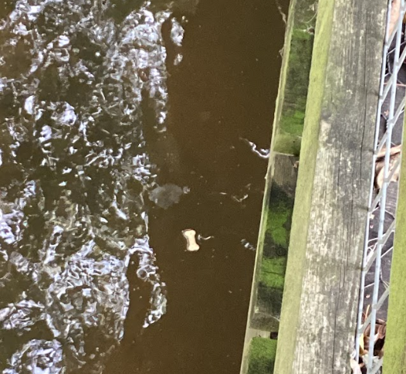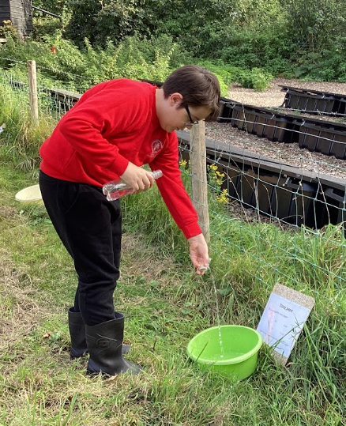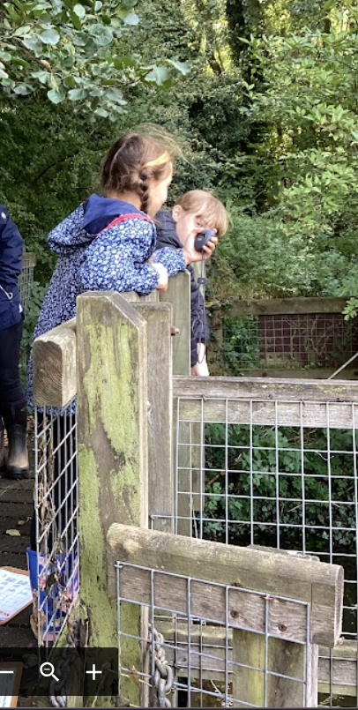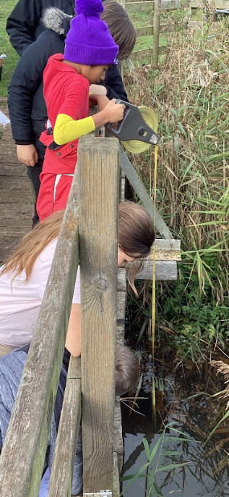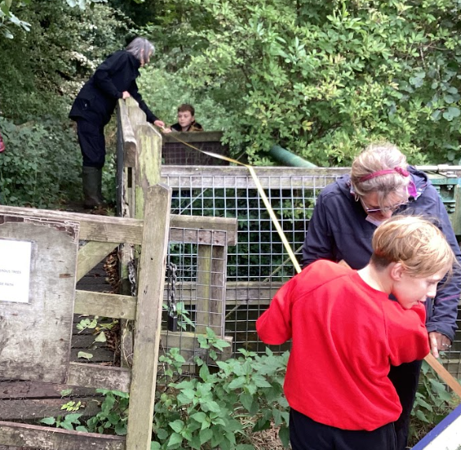

In summary it was a very successful morning that allowed children to integrate their Mathematical skills into different subjects across the curriculum. Adults noticed that the children were unconsciously applying a range of Mathematical skills and were completely engaged.