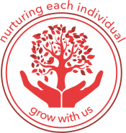

Brampton CE Primary School Article
Outdoor Learning
Last half term Upper Key Stage 2 took part in a six week outdoor learning sequence that allowed children to learn curriculum skills and knowledge based around a theme. We used a thematic approach to engage the children and create memorable experiences. During our recent Ofsted inspection, the lead inspector fed back to us that our children spoke in more detail about knowledge they learnt when taking part in projects rather than single subject sequences of work.
The theme chosen was ‘The Big Bird Project’. We used information from the RSPB website to support us in developing a unit of work that would encourage children to connect with nature and help to increase UK bird numbers as there has been a steady decline in the UK.
As part of the project we wanted to provide children with opportunities to develop: PSHE skills, DT skills and Maths skills whilst working in the outdoors.
The children’s main aim was to design, make and evaluate a bird box for birds to nest in (DT). The box had to be based upon a wooden frame and needed to be sold for a profit (PSHE- enterprise). The children learnt about aspiring individuals and debated upon skills and qualities of an entrepreneur.
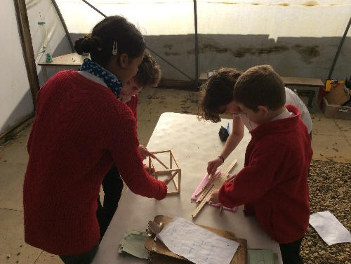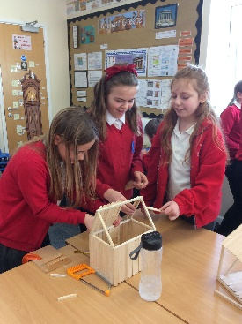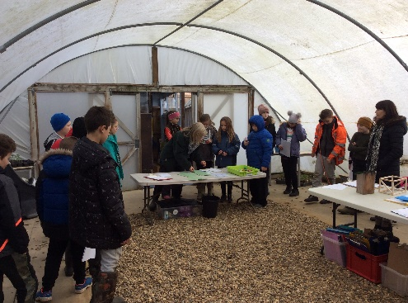

Additionally, the children worked with our Outdoor Coordinator to: develop knowledge about different types of birds, create bird feeders and set up their own hives. The children then used this knowledge to take part in the ‘Big Garden Bird Watch’

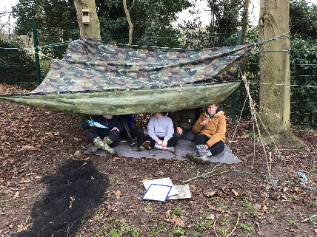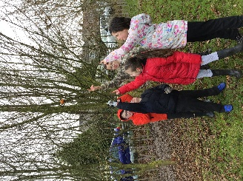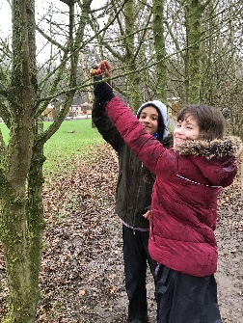

At the end of the project the children entered their data to the ‘Big Garden Bird Watch’ and developed a bird box ready to sell for a profit. The children said:
- We enjoyed learning outdoors the lessons felt calmer.
- I liked making my bird box and can’t wait to see if a bird nests in it.
- Since the lesson I think others have been kinder to nature
Our children also gained knowledge of DT vocabulary; they were able to talk about their product using technical language such as beams, columns, slabs, triangulation, stability and bracing.

