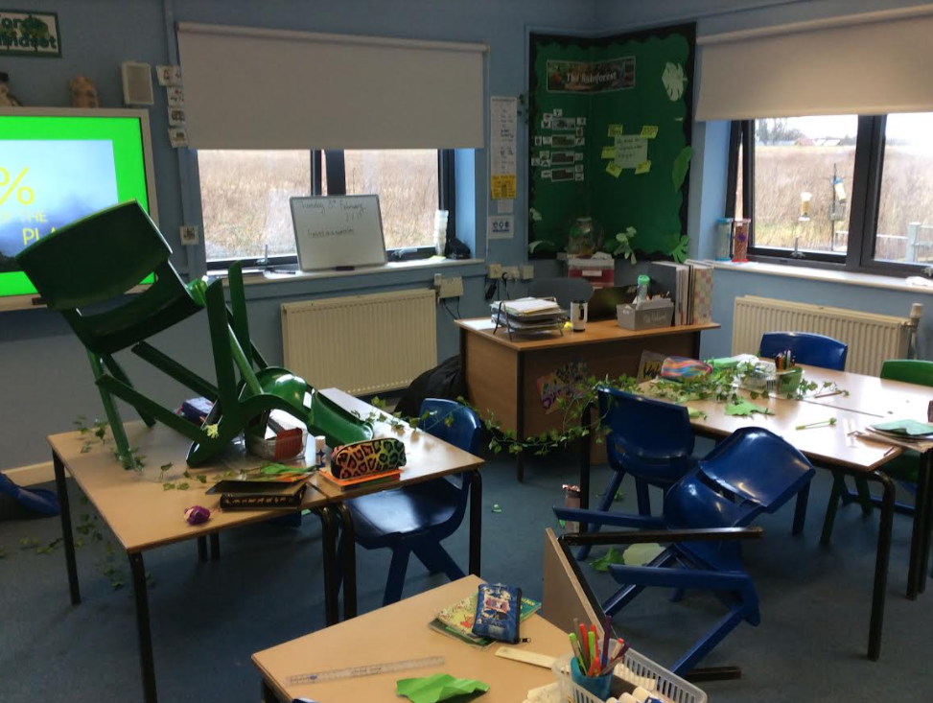

Owls class investigated the impact of deforestation on the rainforests around the world.
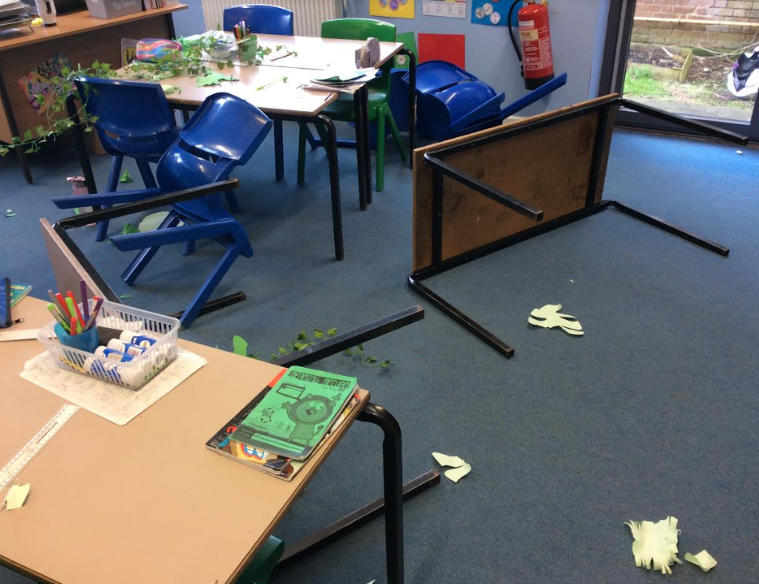
After lunch, we returned to find our classroom have been destroyed. We have explored the threats and their impact on this habitat (including endangered animals) as well as looked at preservation. We created poster to raise awareness and answered our key question of ‘Why should rainforests matter to all of us’ in an explanation text.

