Save our seas recycled art project
Children across the school helped to create a wonderful narwhal from recycled items to display at the Suffolk Show to highlight the importance of putting waste in the right place, so it doesn’t end up in our waterways and seas, causing harm to marine wildlife and ecosystems.

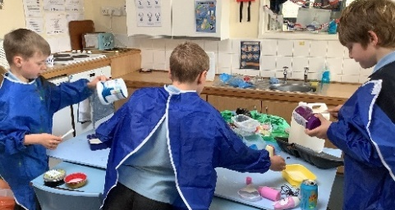
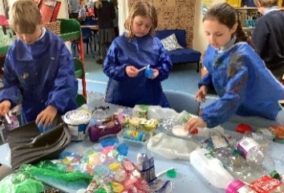
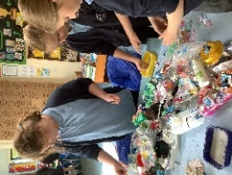
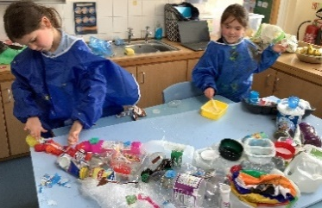
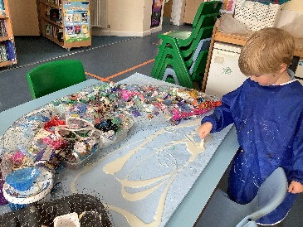
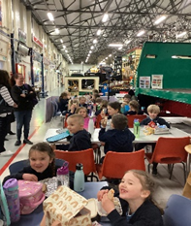
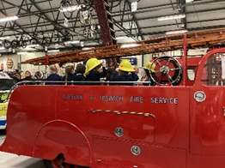
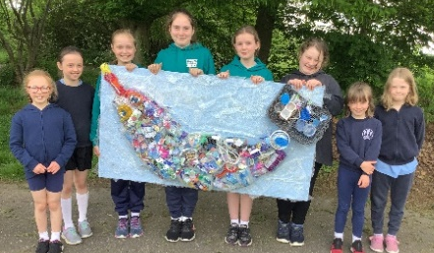
The highlights of last term must include our trip to Ipswich Transport Museum. While there we had the opportunity to try on old fire helmets and sit on various types of past transport. These included old fire engines, trolley buses, trams and coaches. We even got to go in a house bus!

Badgers class have had a busy half term, beginning with a trip to the school farm fair in our first week. There we dug for potatoes, tasted venison burgers, apple juice and honey, looked for the queen bee in a hive, stroked the rabbits and guinea pigs, watched working dogs and learned about robotic machinery and how it is used in farming.
