Maths Across the Curriculum
Hedgehog Class
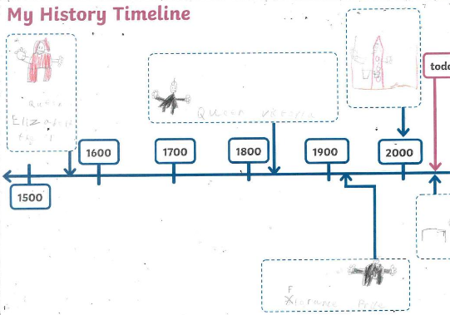
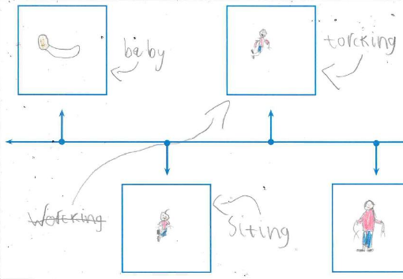
Hedgehog Class created their own timelines based on their life events, placing them alongside historical events that they have been learning about. They demonstrated good understanding of chronology.
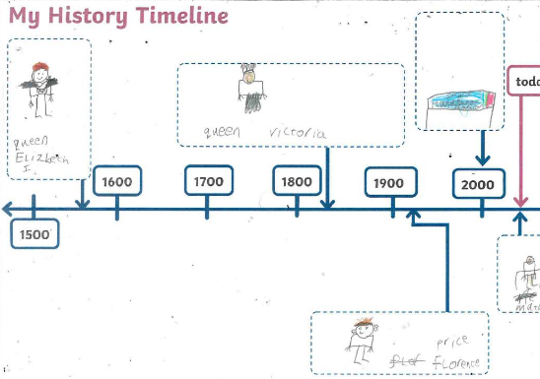

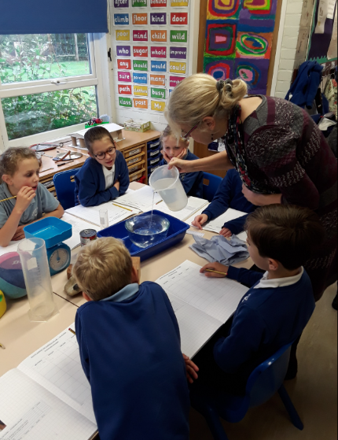
Squirrel Class
Squirrel Class investigated Archimedes' Principle and measured the density of a variety of objects, during our maths across the curriculum day. They weighed the objects, put them in a bowl of water and measured the volume of the displaced water. They then used the equation
density mass volume
to work out the density. The children found out the heaviest item was the most dense.
This links in with their topic on Ancient Greeks.
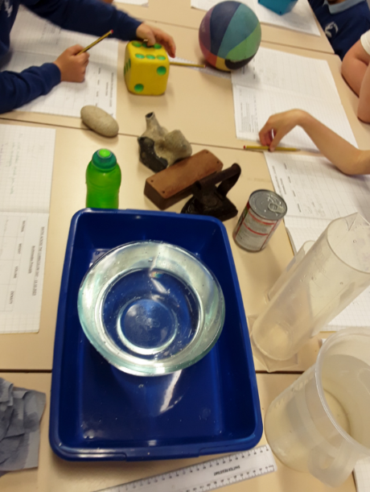
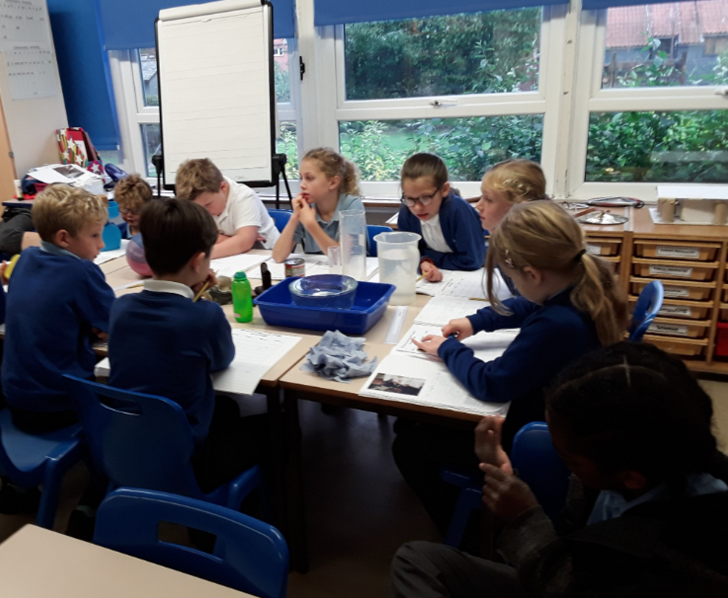
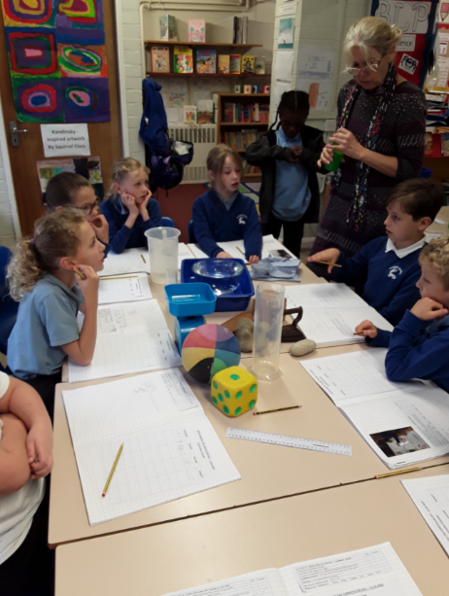

Kestrel Class
During our maths across the curriculum day, Kestrel Class made models of Stonehenge using Lego. They then calculated the volume of each block. Afterwards, they made a scaled model using clay. This linked to their work on Stone Age and Iron Age.
