Hartest Church of England Primary School ~ Summer Term 2022
Welcome to our Summer Term Newsletter from Hartest Primary School.
What a wonderful culmination to our busy half term! On Thursday 26th May we welcomed our families to our Jubilee event on the school field. Each class planned and created stalls, activities or games with a royal theme. There was all sorts of fun to be had … from Splat the Royal Rat, Where is the Queen hiding? to Guess the Name of the Corgi! It was great to see everyone enjoying themselves!
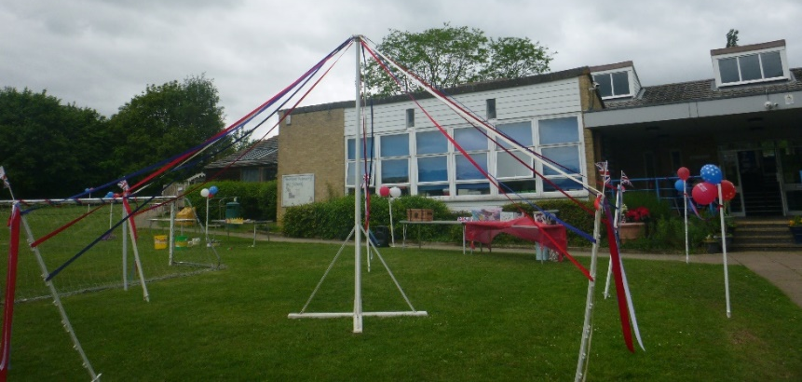
Friends of Hartest decorated the grounds so patriotically – even the flower beds had a red, white and blue theme!
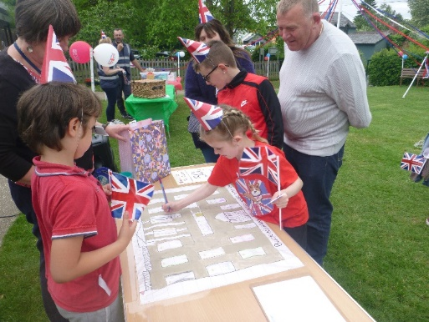

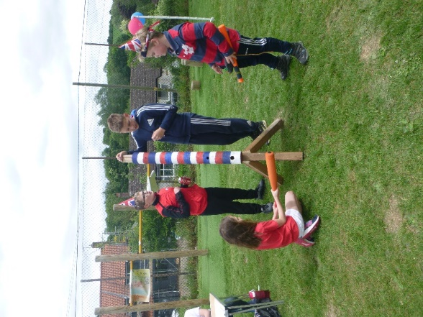
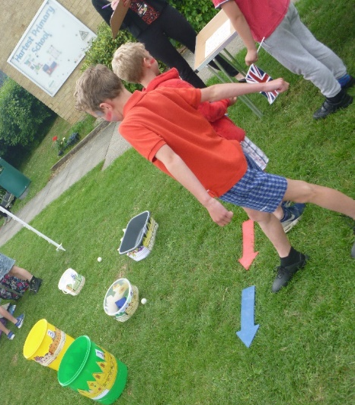
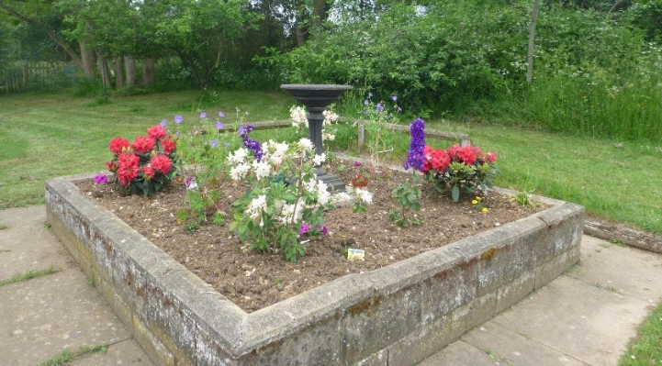

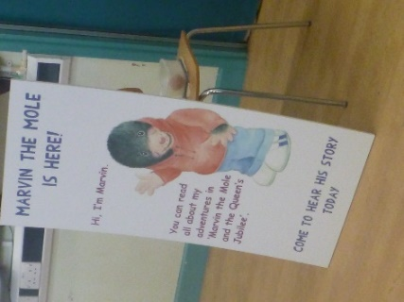
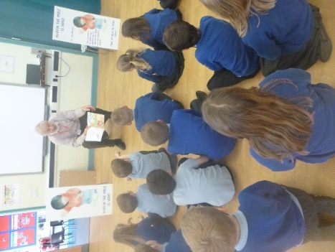
As part of our World Book Day celebrations in March, we welcomed Gerald Watts, author of Marvin the Mole. Gerald talked to the children about their favourite books and authors, the writing process and how he came up with the idea of Marvin. He also explained his decisions over the front and back cover, and how he rejected the first illustrations of Marvin because they were too scary! Gerald read the story to the children and then had a Q&A session afterwards. We really enjoyed Gerald’s visit.

Community project at All Saints Church
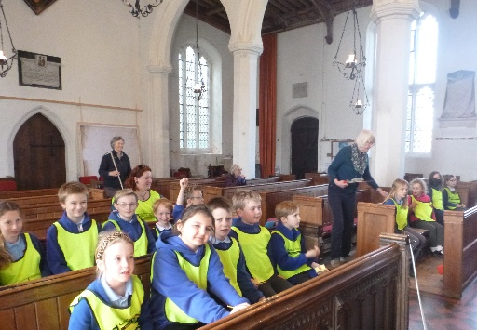
The School and Eco Councils visited All Saints Church. We are working alongside local residents, Karen and Nicky, on a community project to develop a range of learning opportunities using the Church building. The children had some wonderful ideas and also thought carefully about the building itself, the people that have used it, the village around it as well as the skills and materials that were used to build it.
Both Karen and Nicky have spent a great deal of time putting the outline of the project together and we are delighted to be involved in this exciting community project. Karen sent an email of thanks following the visit, commenting on “the enthusiasm and interest of the pupils. What a lovely and lively bunch!” We are looking forward to the next phase of the project whereby the learning opportunities will be mapped out, carefully aligned to our curriculum and shared with school staff during the Summer Term. A huge ‘well done’ to the School and Eco Council – you were indeed amazing and a credit to Hartest CE Primary School.
Festival of Suffolk Torch Relay
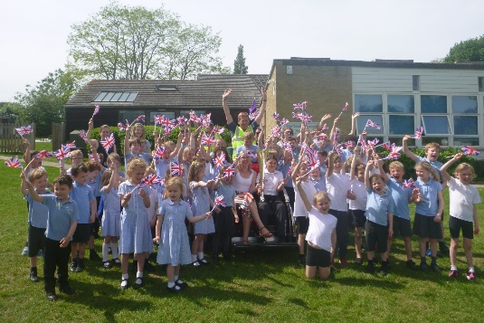
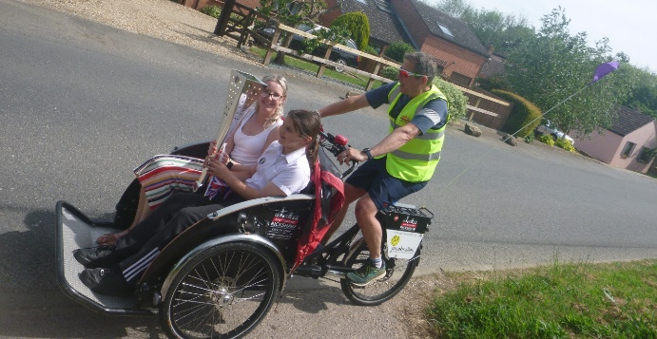
During May we were lucky enough to see the Torch Relay (part of the Festival of Suffolk and the Platinum Jubilee celebrations) that came through Hartest. Great anticipation and excitement built as Mrs Miller alerted us that the relay was at Boxted at 2:30pm. We equipped ourselves with our Union Jack flags and lined the school field in readiness. We had a super vantage point and eagerly waved our flags whilst we waited! At 2:45pm – perfect timing before the end of school – the torch arrived! 😊 Miss Lewis and Demi were chosen as torch bearers and carried out their role with enthusiasm with the whole school community cheering and waving! It was most uplifting and we were delighted to have played a part in the torch’s 588-mile journey around Suffolk.

Warmest wishes from all at Hartest Church of England Primary School.

