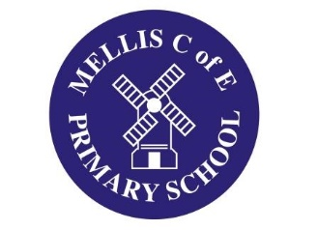

‘Maths through RE and Art
Article for DMAT Website from Mellis CE Primary
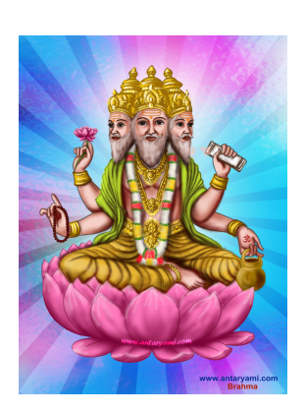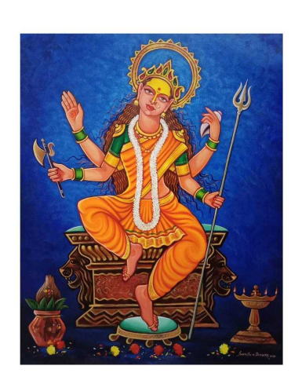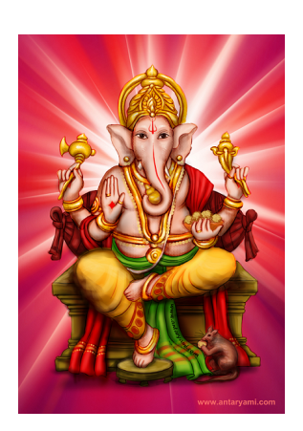

‘Hindu Gods and Goddesses: mathematical abstracts!
For the annual DMAT ‘Maths through the Curriculum’ day, Mellis School decided to focus on art and RE. We planned this with input from Mr Derek Johnson, Art Director at West Suffolk College, whose work in combining art with maths, RE and science has attracted national recognition, even being mentioned in Parliament!
We decided to concentrate on knowledge of space and shape, along with critical (and often under-rated) fine motor skills in terms of accurate ruler use. We introduced the huge variety of Hindu Gods and Goddesses and discussed key characteristics, before looking at the properties of different triangles – as well as how to draw them accurately!
We then worked on making abstract images of the different Hindu deities using only triangles, pencils and rulers! Using tracing paper and a choice of deity, the children practiced the concept before heading to the main task – working in a group to produce large scale abstracts, again using only triangles of different shapes, sizes and proportions to represent the multi-limbed and multi-headed Hindu Gods and Goddesses. They then used pointillism art techniques to add texture and colour before we mounted the finished articles on long, wall mounted ‘hanging scrolls’.
A huge part of the experience and indeed fun of it all was that we formed each of the teams into mixed age groups and focussed on the team-working aspect that is so important. It was genuinely exciting to feel the ‘buzz’ around the School, and the sort of day that emphasises the very best parts of the job. We felt so proud of the finished abstracts that we put on an impromptu ‘pop-up’ art exhibition for the parents!
A grand day all-round!
