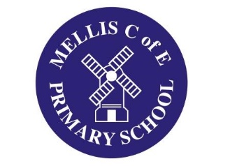
DMAT Website Article from Mellis CE Primary July 2022

Celebrating the Queen’s Jubilee!
Mellis School has a long tradition of celebrating Royal events with a whole school street party, and the Queen’s Platinum Jubilee was no exception! With great support from the Mellis School Parents’ Association a fantastic spread was put out for the ‘party on the playground’; we even had a visit from the Queen herself – sort of! To make things even more memorable, the Platinum Jubilee Torch procession came through Mellis, and the entire School turned out to wave it on. Our Head Girl and Head Boy had the honour of carrying the Torch on the ‘E-Rickschaw’ around Mellis Common before it went on its journey. The School even got a front page ‘splash’ in the local newspaper!
Very much a once in a lifetime event!
