DMAT Website Article from Mellis CE Primary Summer Term 2023

Coronation Commemoration at Mellis CE Primary School
The school has always marked Royal events, and the Coronation – a specific event not seen for over 70 years – was no exception!
In the first instance, our Year 5s set about making a lifesize reconstruction of the 700 year old Coronation Chair (not, to be clear, a throne!) originally commissioned by Edward the 1st in 1301! They constructed this from up-cycled corrugated card, balsa, paint and glue from photos and plans. They also made the Stone of Scone (pronounced ‘scoon’) to represent the Scottish Kings and Queens from fruit cases and Modroc! Everything was given a coat of paint, but also had graffiti applied! The real thing was subject to generations of school boys in the 1700s and 1800s, where people were allowed to sit in the Chair for a penny a time; it only seemed right to add in their own names and dates to our model!
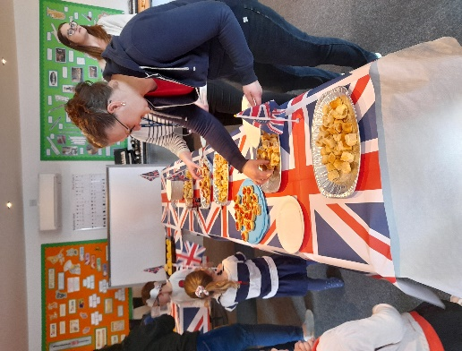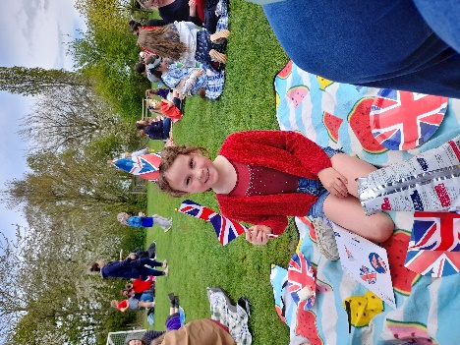

The Chair and Stone were central to our commemorations at School and indeed at the village hall for the village celebrations – it drew much in the way of positive comment!
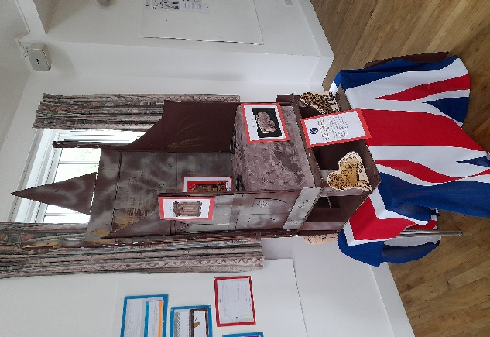
The school also took the opportunity to celebrate together, with a Coronation High Tea on the School fields! It was grand to invite parents and grandparents to bring a blanket, a posh sandwich (with the crusts cut off!) and enjoy a scone and jam courtesy of the Mellis School Parents Association. After the events of the last couple of years, it was wonderful to see all the members of the school community together!

