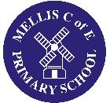

'Easter at Mellis CE Primary - 'Egg Jarping'!

Fun has been in generally short supply over recent months, and the School decided to celebrate Easter with the ancient and noble sport of 'egg jarping'! This Northumbrian tradition has the participants hard boil eggs and decorate them - before trying to crack their opponents egg without cracking their own! One person holds the round end of their egg upwards, while the other attempts to crack it with the sharp end of their own egg in a short motion known by afficianadoes as the 'dunsh'! Each player then flips positions!

All good fun, and a great way to mark Easter as these pictures show!'

