Ringsfield CofE Primary School

The mustard seed “is the smallest of all seeds, but it becomes the largest of garden plants; it grows into a tree, and birds come and make nests in its branches.”
Matthew 13:31-32 (New Living bible)
Maths in the curriculum at Ringsfield Primary!
EYFS
Nursery have been busy sorting the conkers and the children were encouraged to touch each conker to ensure accurate counting. There were also some hedgehogs with the numerals 1-5 and the children were counting out the correct numbers of conkers to give to each one.
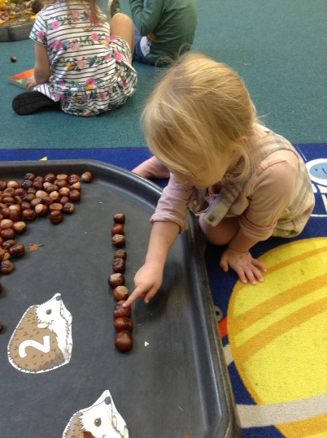
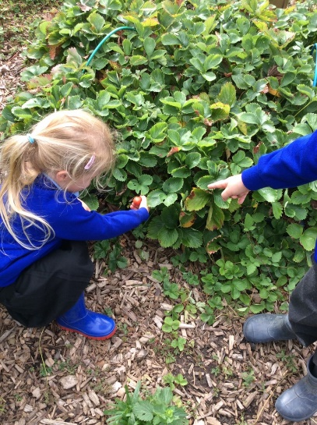
Reception have been learning lots about autumn and investigating why it is so late this year. We have observed the local environment and discussed why the trees still had leaves and the garden produce was still growing. The children were especially excited to find some red strawberries and we counted how many we could find.
Year 1 and 2
During a circle time activity, the Year 1 and 2 class played the game 'Messy Bedroom'. They tried to keep their bedroom tidy by putting all the items into the other team's bedroom. When the timer went, they counted the objects in their bedroom and looked to see which team had the greatest number of objects and which team had the fewest, linking to their learning on place value. The children then talked about whether the number of items was an odd or an even number.
Year 3 and 4
Earlier in the term the Year 3/4 class made a special visit to our local church. The 70-year-old church roof was being rethatched and the children prepared a time capsule which was placed in the new thatch! The children were given a talk about the thatching process and spent some time learning more about the different features of the church. Following the visit, the children completed a maths investigation. They were asked to work out how many square metres of reed covered the roof. The children worked in small groups and were given access to squared paper, place value counters and dienes blocks. The children also used their understanding of multiplication facts and doubling to solve the first part of the investigation.
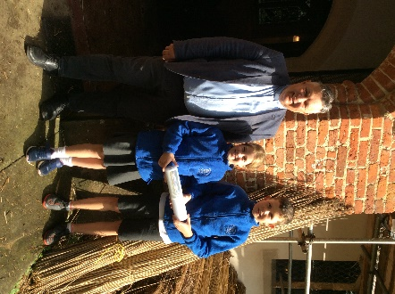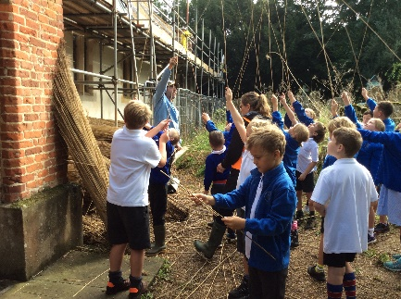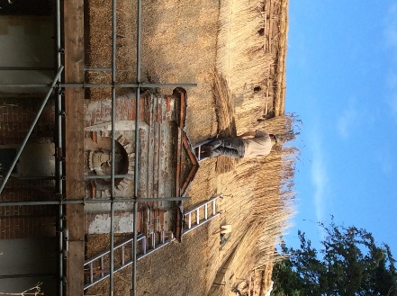
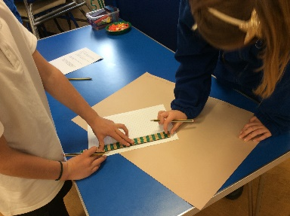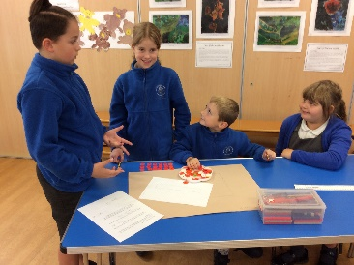
As an extension activity the children were asked to calculate how many bundles of reed would be required to thatch one and then both sides of the roof.
Year 5 and 6
During their recent field trip to Redgrave and Lopham Fen, the Year 5 and 6 class measured different things, using their skills to help them come to a conclusion about aspects of a river. They measured the width at different intervals to work out what happens to the width of a river from the source to the mouth. The children then measured the depth for the same reason. They then measured the air and water temperatures in order to find the difference and think about why the differences occur. The children were unable to measure the flow of the water because the sluice gate was shut so the water was not flowing but they did discuss how they would do this by timing how long it would take an object to move a metre from a given starting point.
