News from St Mary’s School Autumn Term 2023
It has been a really busy term at St Mary’s! The children have enjoyed a range of sporting events and extra-curricular opportunities. We have devoted lots of extra time to reading activities and the children have also embraced lots of new learning, particularly in maths.
Mathematics
At the start of this academic year we introduced a new mathematics scheme. The Ark Curriculum Mathematics Mastery programme is a fully resourced curriculum. The developers of the scheme were pioneers in the mastery approach to teaching maths. This early work led to the DfE adopting the mastery approach to teaching mathematics.
We are already able to see the benefits of the scheme for teachers and pupils. Our subject knowledge has been strengthened and teachers are more confident in their maths teaching. Children are displaying significantly more understanding and enjoyment for maths.
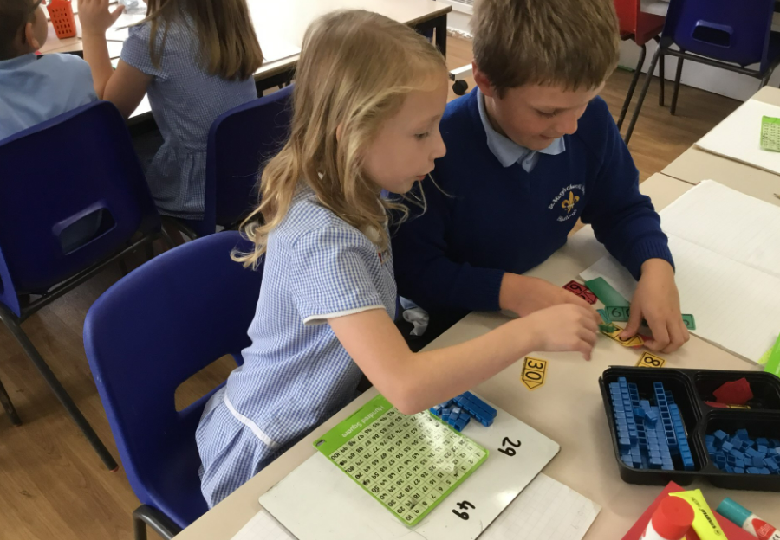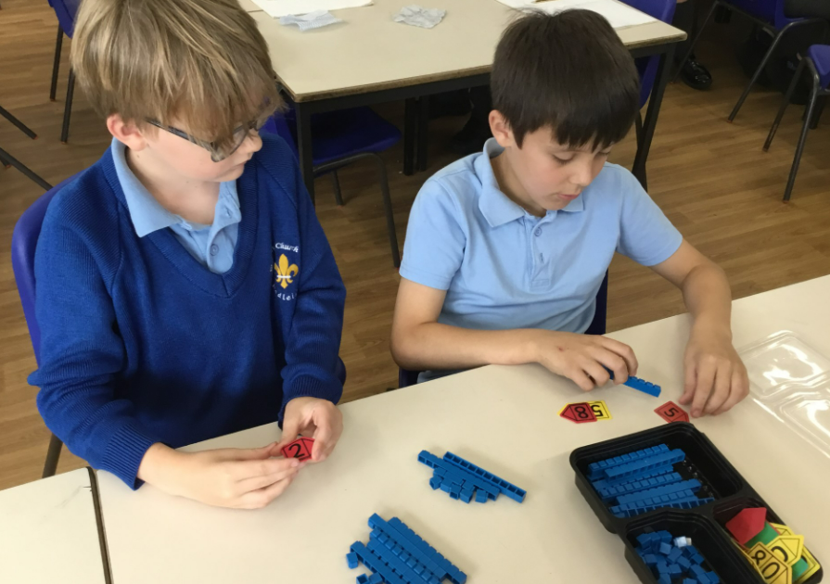

Forest School
During our ‘Discovery at the Deanery’ sessions, the adults relive a wonderful experience from their childhood. The children used hand drills to put holes in conkers and then thread some string through. The children had traditional conker fights, attached them to sticks to make fishing rods and even necklaces. It’s always a lovely thing to be able to share past experiences with the next generation. Thank you so much to the Hadleigh scouts and 4 Life Landscapes for donating rope for our Forest School activities. We have had great fun this term learning how to build rope swings and bridges! If you have any rope which you no longer need it would always be appreciated!
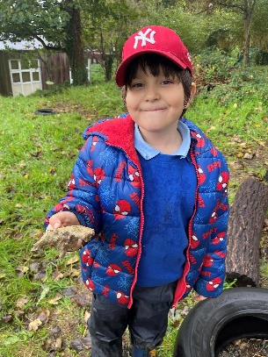
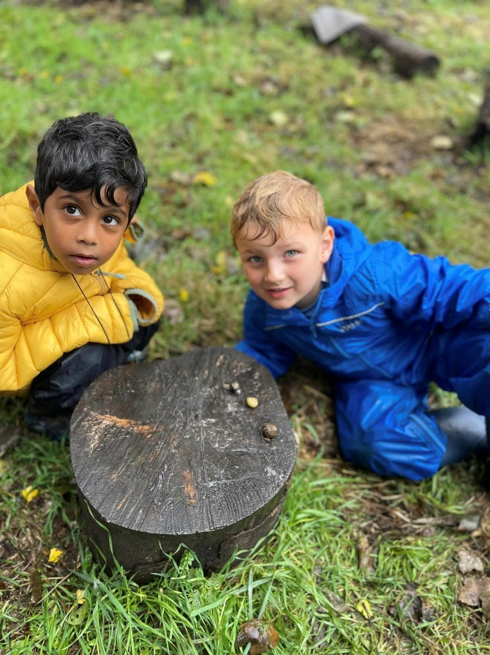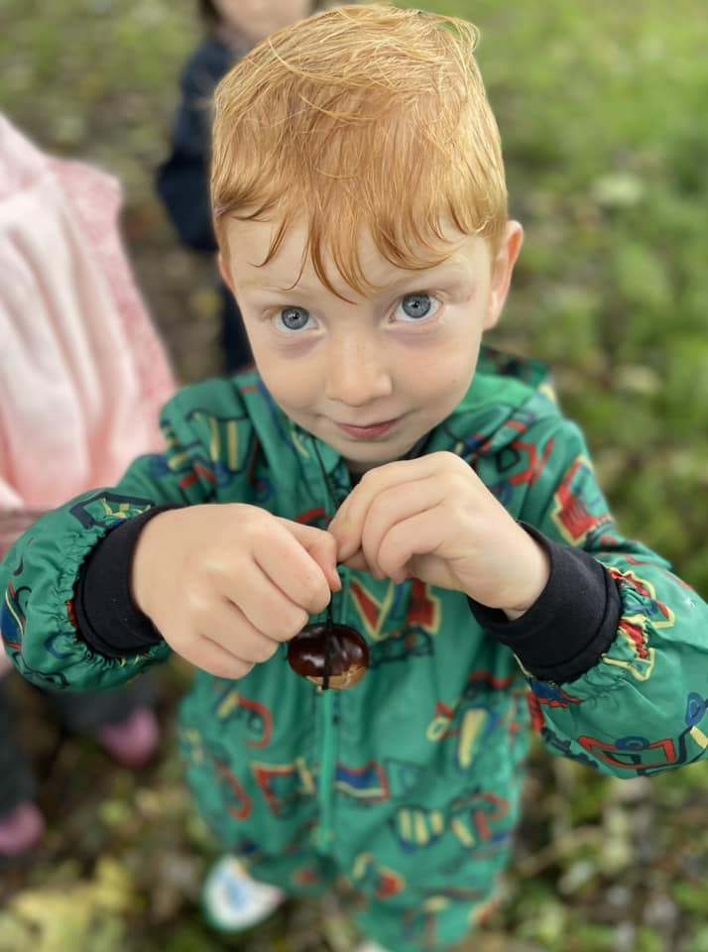
In October, we celebrated national Forest Schools day and the rain didn’t stop us enjoying it! We drilled conkers, made friends with snails and built a den to keep us dry whilst fishing! Also, we had a very special visit from Hana Hawk who’s a Forest School legend and she passed on so much wisdom to both children and adults. The children love exploring the natural world and they found a beautiful furry friend who they found out would eventually become a moth. The children have also enjoyed sitting and listening to the birds.
As well as building dens, the children cleared a space and helped create our mud kitchen. There are some new Forest recipe cards in the mud kitchen, the children enjoyed exploring the site to find the ingredients. River Rose is hoping the children will make some invisibility potion!
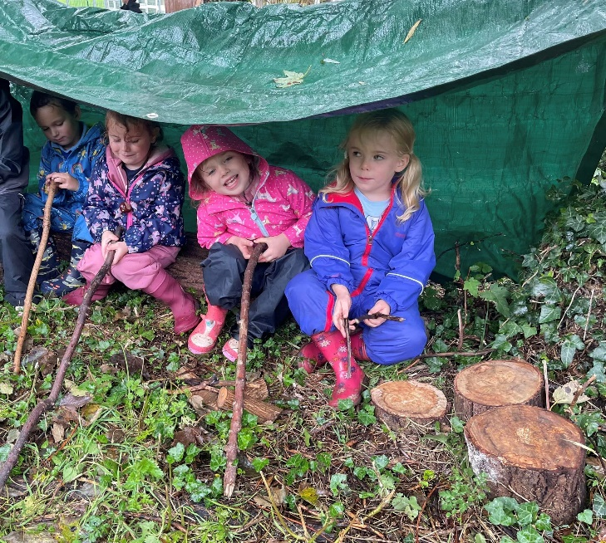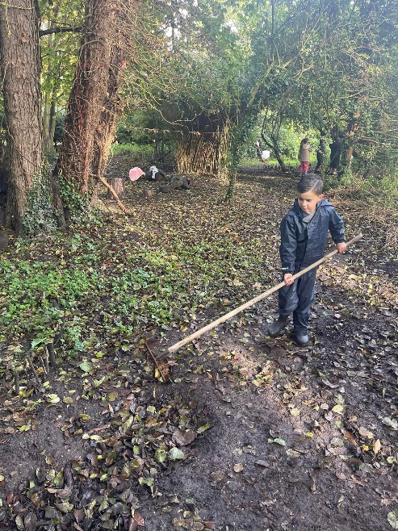

Whilst Oak class have been busy recently, helping to repair our site at the deanery, (We lost most of it during the flood), Year 2 were lucky enough to spend time at our developing, “mini discovers” site behind the school. What a fun time they have all had!

Dodgeball

We had the pleasure of taking ten eager and delightful Year 6 pupils up to Hadleigh High School this term to compete in a dodgeball tournament. We faced 12 games in total and won 10 of them. St Mary’s were crowned winners of the tournament after a very intense and tight last game! Well done to the ten children who took part. They showed amazing teamwork, fair play and lots of determination! We are really proud of them all!

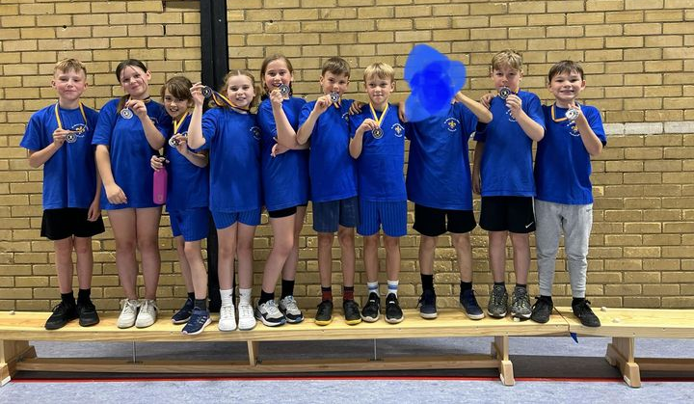

Christmas Song
Year 3 and members of the School Council and Worship Council had the pleasure of visiting St Matthews Church, alongside all the other schools from our Multi Academy Trust, to record a Christmas song for the charity 'Save the Children'. With limited time to practise, the children were amazing at learning the song off by heart ready to perform, which also included dancing in Christmassy clothes! What a delight they all were, representing St Marys brilliantly! We can't wait to see the end result!

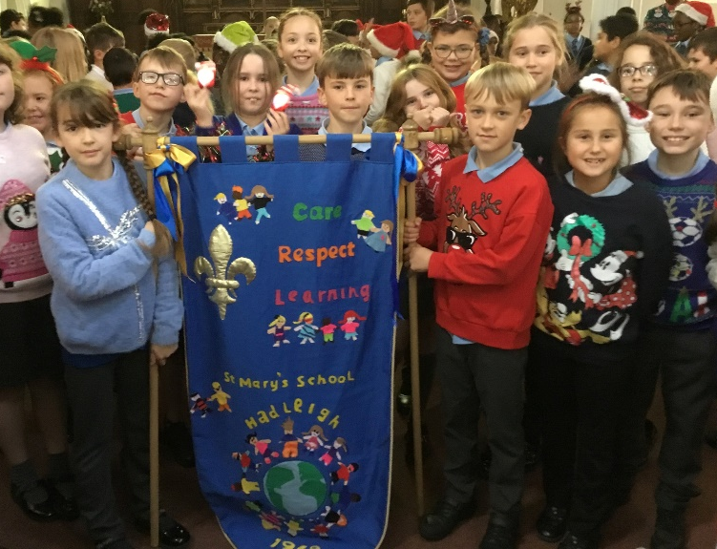
Football

Team St Mary’s attended an U11 football tournament at Whitton sports centre earlier this term. What fantastic football they all played - just brilliant to watch! They played six games: won 4, drew 1 and lost 1. Special congratulations go to Milo who won the fair player award for having a brilliant attitude and supporting all of his team mates. The children represented the school really well, displaying our values through their behaviour, and we were really proud of them.

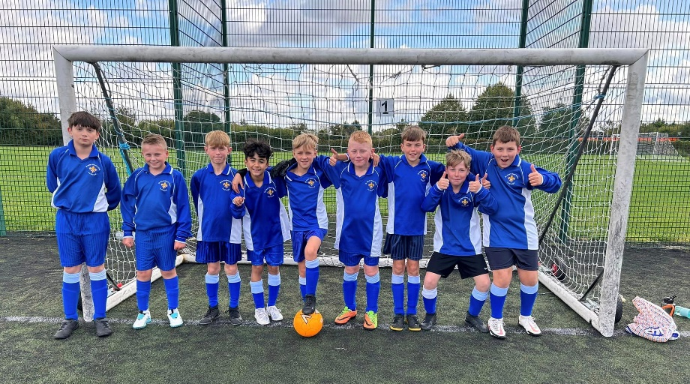

Harvest

At the end of September, the children delivered a joyful harvest assembly, strongly linked to this term’s Christian value of thankfulness. All of the children were involved in the celebrations, and they did brilliantly! Children from each class presented work they had been doing to celebrate Harvest. Children shared research about where food comes from and Food Banks, art work based on food, Harvest prayers and a song with sign language.
We also collected lots of food items for the Food Bank in Hadleigh! Many thanks to everyone who donated to this good cause. A visitor said: “I was impressed with the way even the youngest children were prepared to stand up and present their work in front of the whole school, and with the respectful listening shown by other children.”

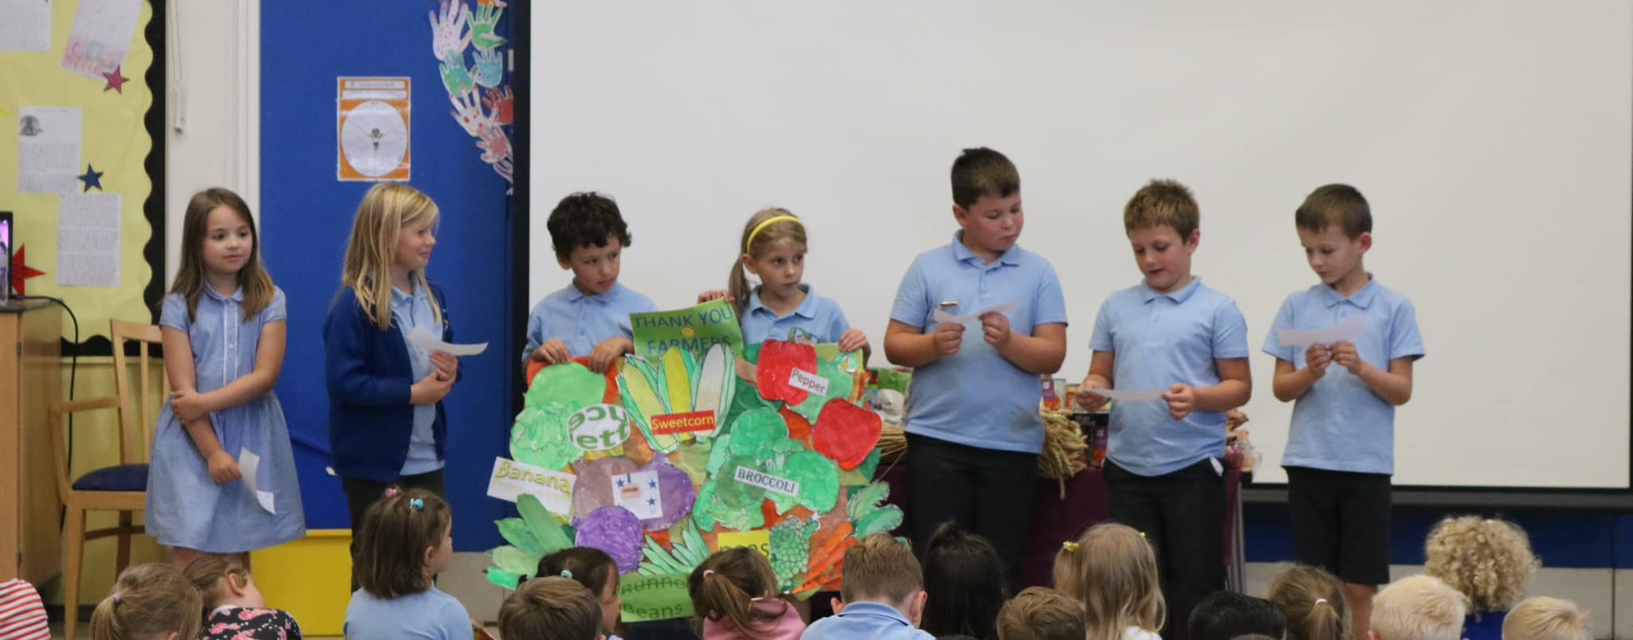

Dragons!

In Rowan class we have been looking at the book ‘How to Train Your Dragon’. The children have linked their learning across the curriculum and, in art, the children have designed and made their own dragon eggs! The children were really proud of their creations. Fantastic work, Rowan class!

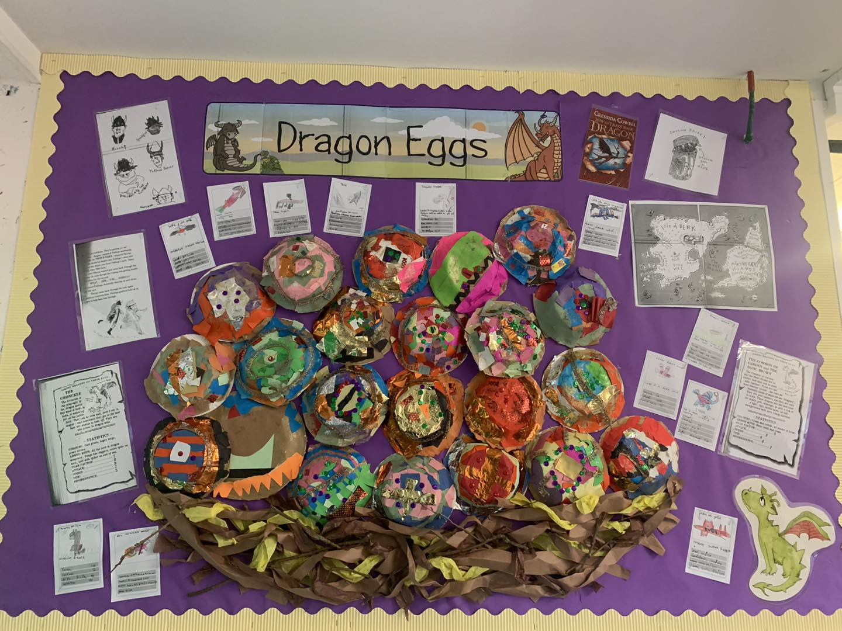

Tag Rugby
Years 1 and 5 have been having so much fun learning Tag Rugby skills with coaches from Hadleigh Rugby Club. Thank you to Ian, Lesley and Sarah for these enriching sessions. We hope lots of children will explore what Hadleigh Rugby Club has on offer. These regular sessions have been such a great opportunity to keep active, make friends and be part of the local team.
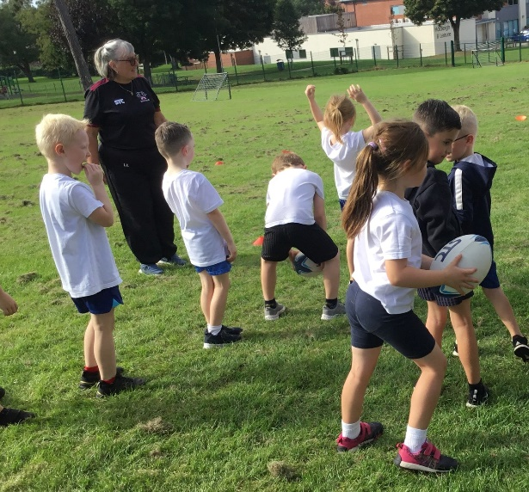

Pen Pal Club

We are very lucky to have a school in Thailand who would like to find out about children in England. We have lots of children who are very enthusiastic about being a pen pal.
The children have started to write our letters and cards to the children in our partner school in Thailand. We are really looking forward to receiving their replies and finding out more about what it is like to live in Thailand. Thanks to the huge group of children who have dedicated their time to this and shown such a positive attitude.

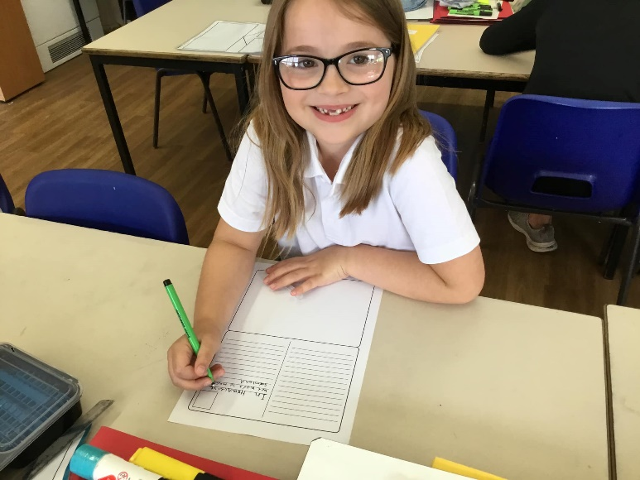

Eco Club

Lots of children attend Eco Club every week. The children explore their environment and learn about caring for the world around them. Recently, it was ‘world save the rhino day’ and in Eco club we found facts about rhinos using iPads. We also drew pictures of rhinos and made posters. Well done Eco club for reminding us how important it is to look after these amazing animals.

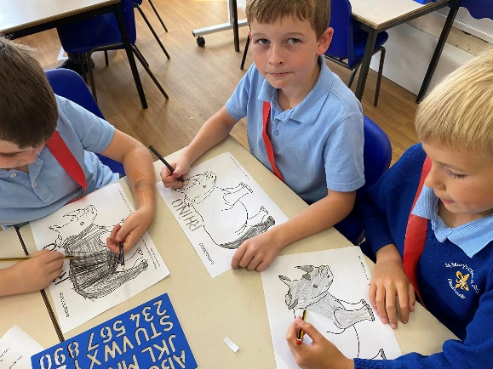

Cross Country

We had a really lovely morning at Hadleigh High School participating in the U11 and U9 cross country event. Our U9s ran 800 metres & our U11s ran 1500 metres! All of our children showed fantastic determination and supported each other superbly.
The overall results were as follows:
U11 boys – WINNERS; U12 Girls - RUNNERS UP; U9 Boys - RUNNERS UP; U9 Girls - 4th PLACE
Well done everyone we are so proud of you, as this is a tough event and you competed so well! Thanks to everyone at the High School who did a great job of organising the event.

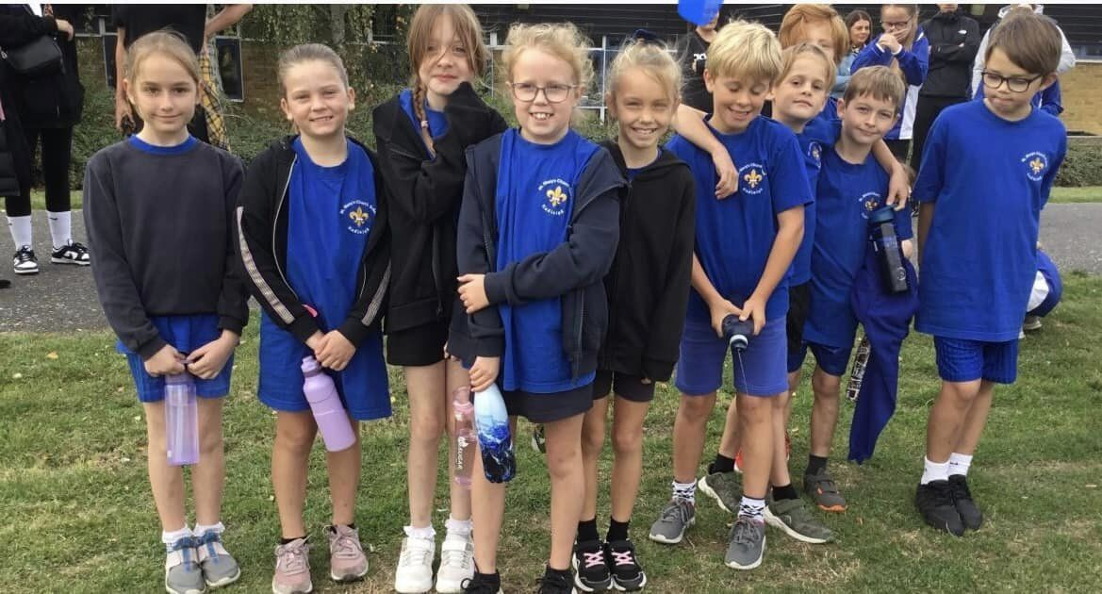

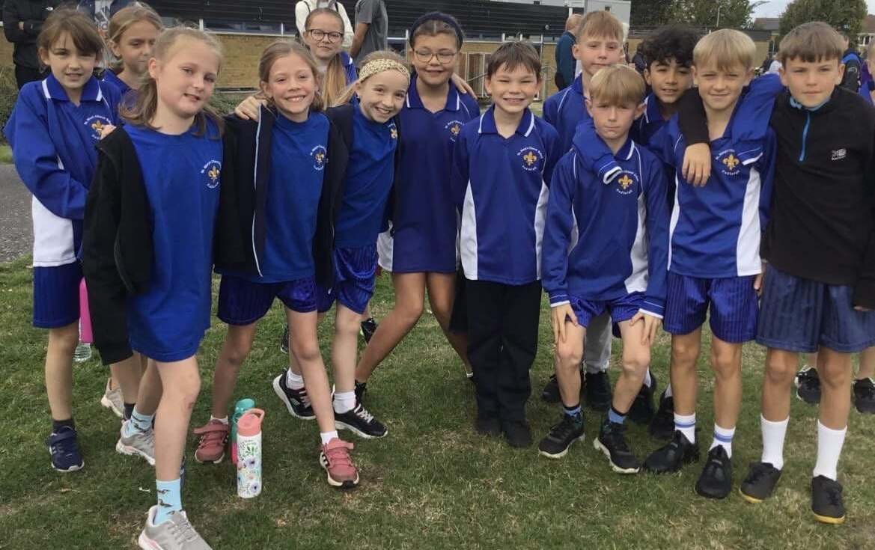

Awesome Art!
The children in Year 5 have had a go at weaving. They worked in groups to design and weave their patterns into their frame. The children worked brilliantly together and had a great time doing something different! As well as their creativity, it was great to see the children developing their collaborative skills.
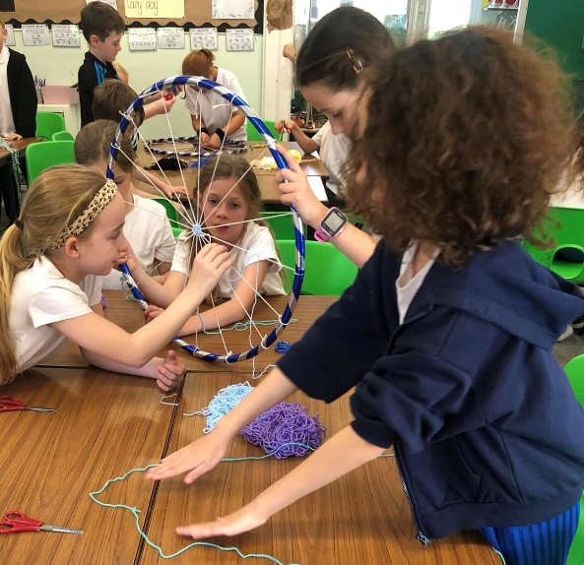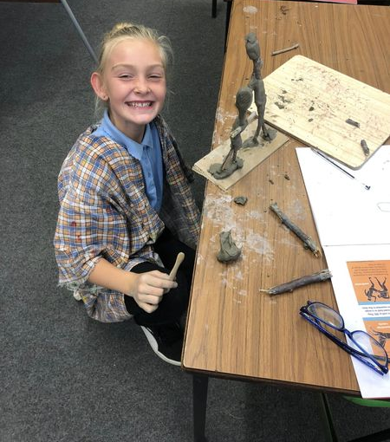

Year 5 have also started some really fantastic sculptures in the style of Alberto Giacometti. They designed a figure using sticks and clay in the style of our current topic, Ancient Greece. They focused particularly on creating Olympic athletes. Watch this space for more messy photos as we Modroc the sculptures!
Beech Class have also been enjoying VERY MESSY but fun lessons in art using Modroc! The children have been creating their own Egyptian style bowls, which will be decorated using our Egyptian designs. We can’t wait to see the final result! This work was inspired by the children’s history topic.
