Stoke By Nayland CofE Primary School
Spring Term News 2023

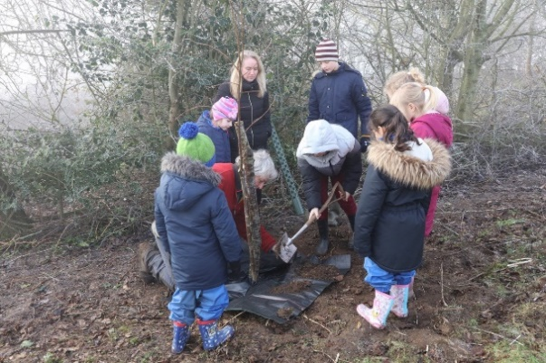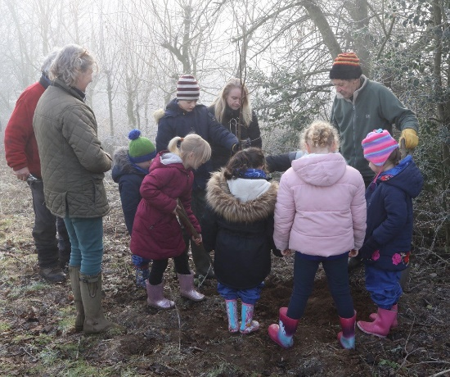

On 8th February 2023 as part of the Queens Green Canopy Project to mark her Platinum Jubilee the children at Stoke By Nayland joined local villagers and landowners to plant seven Lime trees to celebrate her 70 year reign. Despite temperatures being just above freezing the children thoroughly enjoyed themselves

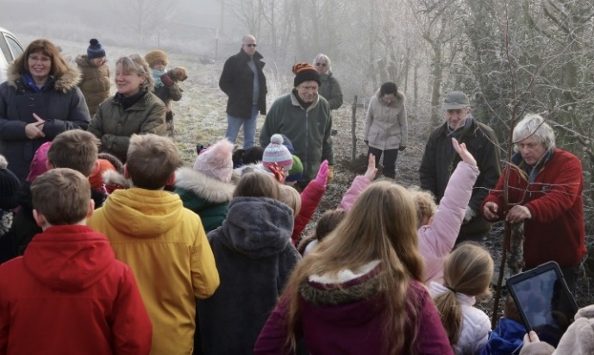

In the same week they were also awarded their Bronze Award from the Woodland Trust’s Green Tree Schools Award and with the planting of their trees are now just two points from their Silver Award which they hope to gain before Easter.

