Maths Across The Curriculum 2023
Tudor Ce Primary School
‘Life in all its fullness’
‘Live to learn and learn to live’
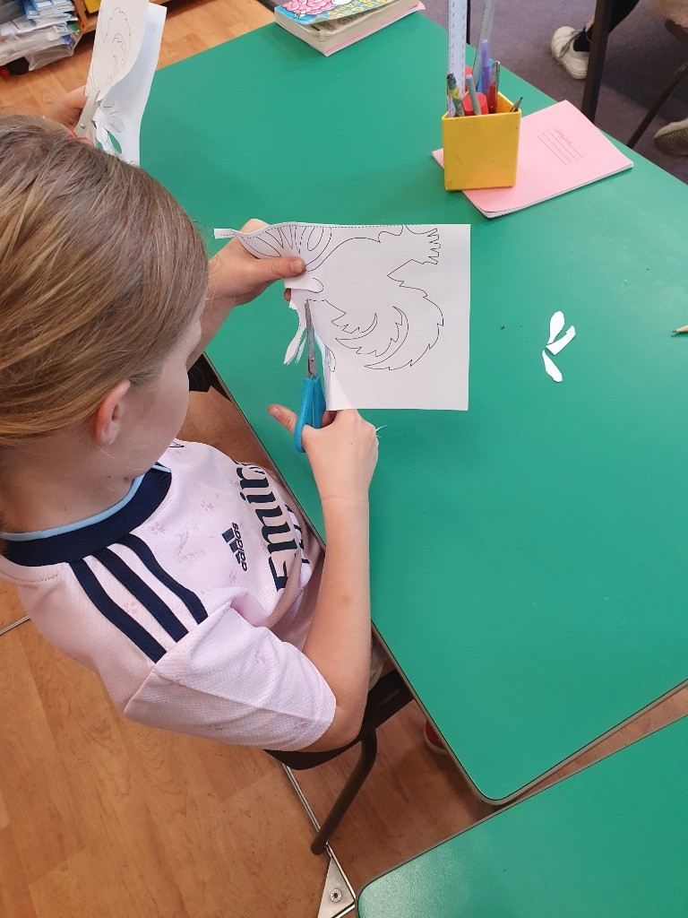
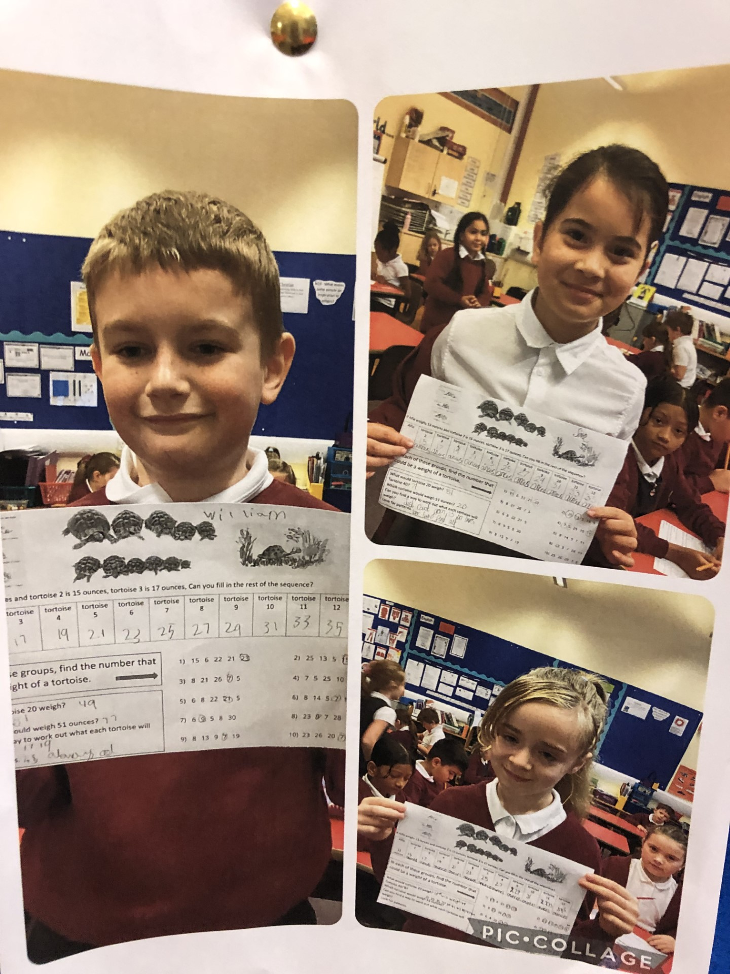
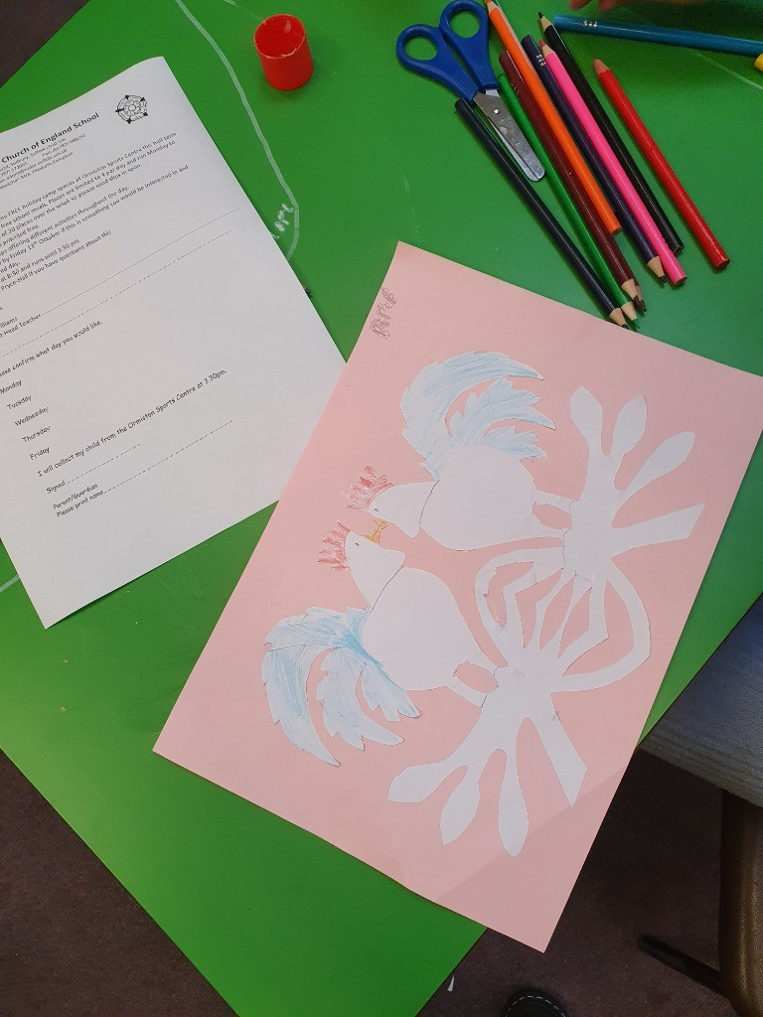
LKS2
We've spent time thinking about how maths can be found in other curriculum areas.
We completed some tortoise maths based on our class reading book Esio Trot and thought about symmetry in an art lesson.
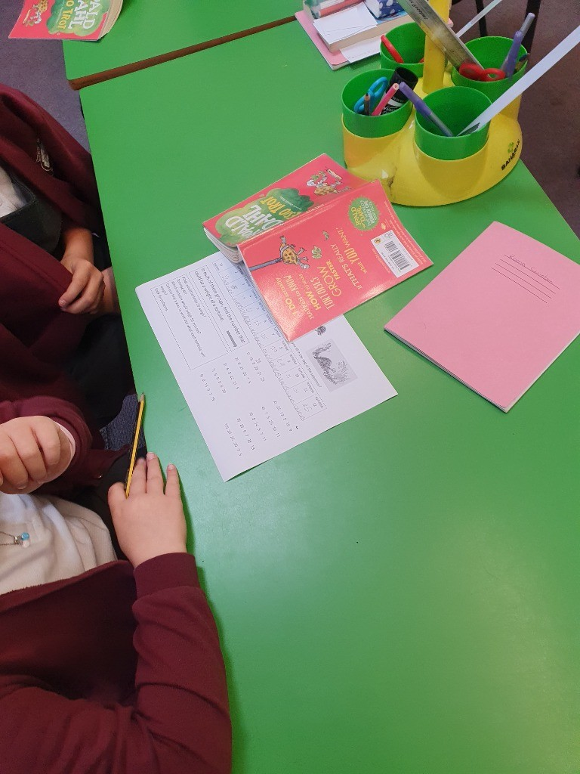
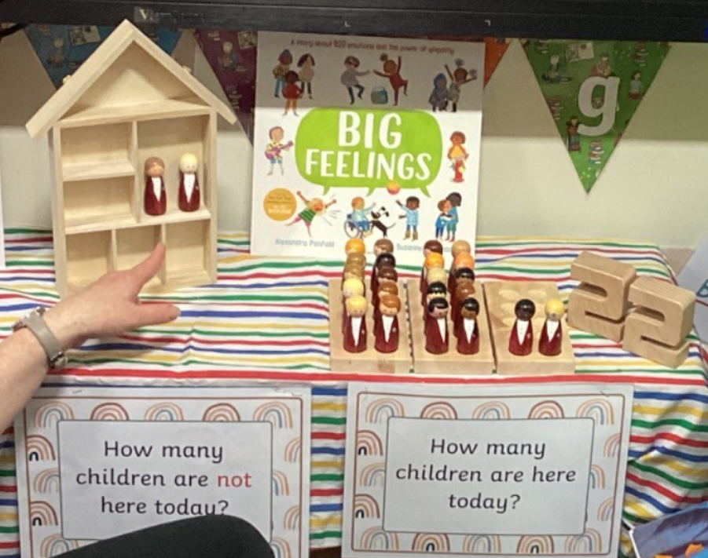
EYFS Maths Counting to help take the Register. This was introduced during maths across the curriculum week in both EYFS rooms
We are using our maths to work out how many children are in class today ! We know that there are 24 children altogether but sometimes we may get poorly or not be able to come to school. We now have little figures that look a bit like us in our uniform - we can use them to work out how many children are at home , in the little house, & how many are here in our ‘10s frame’ holder. It was great to notice that we all look a little different - our hair, our eyes, glasses etc but we all belong together . We are a special class 😊

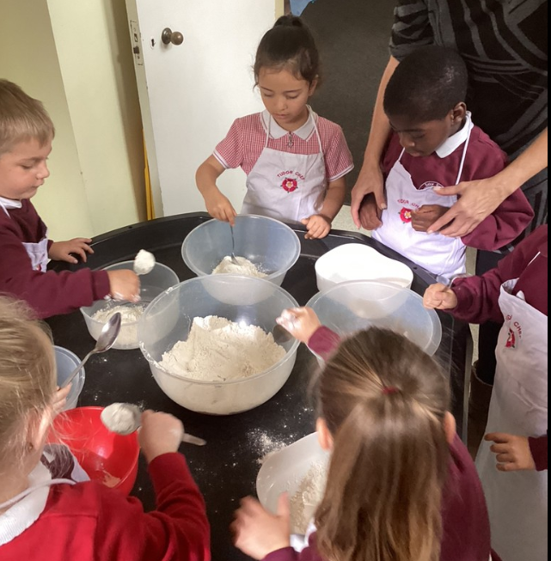
Making Playdough
We made some playdough today! We had great fun squashing and squeezing it, and using the cutters and rolling pins. We had to make the Playdough ourselves too, following a recipe. We measured out the ingredients, and had to do lots of counting to make it work. We have brought some to play with at home 😉
Lots of fun!

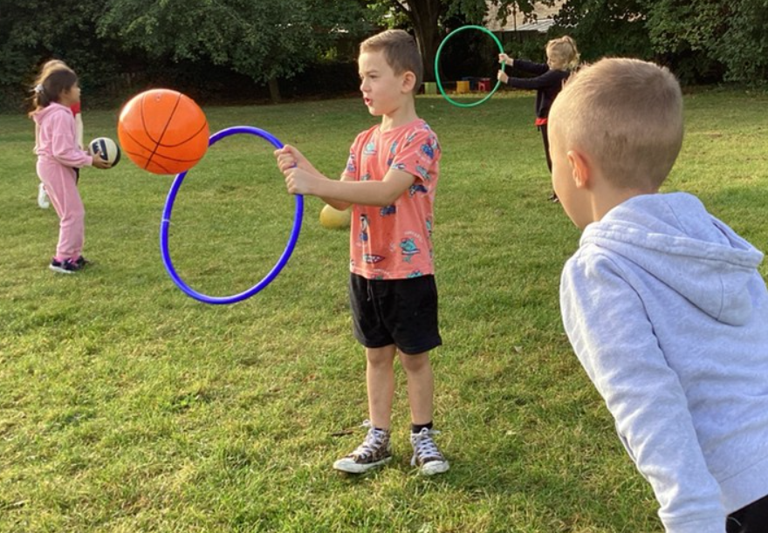
KS1 maths

In PE, we have been working on our throwing and catching skills. We focused on underarm throwing. To do our best throwing and catching, we had to make sure that we were looking at the ball and had our hands ready to catch it. We practiced throwing and catching with a partner, then we had to try throwing through a target. This was trickier than it looked, but we improved our skills by making sure we let go of the ball at the right time!
It is also "maths across the curriculum" week, which reminds us how much we use maths in everyday life, so when we got into our partners, we reminded ourselves how to count in 2s and talked about why there was a group of thee - there is an odd number of children in our class!
Great learning everyone! 😊

Part Part Whole
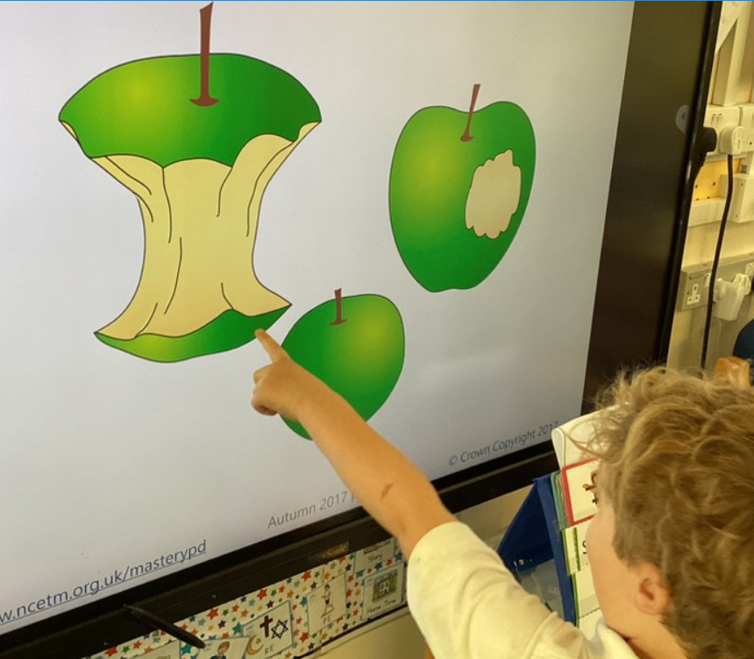
Today we began a new unit in our maths learning. We looked at whole pieces of fruit and discussed what a whole looks like and that it can be made up of parts.
We enjoyed carrying on our maths learning as we ate our fruit…noticing that a part was missing when we took a bite and that we couldn’t put that part back again! We also found out that Miss Moore found it challenging to teach whilst munching on an apple😀
We sorted food pictures into whole and not whole pictures. Some wonderful, independent learning.
We will build up to look at a group being part of a whole set of objects to gain further understanding of part and wholes.

