**Gardening, growing and outdoors!**

We have started some vegetable plots. We lifted some turf and used a rotavator during lockdown and now every Friday for an hour, each class sends 2 children to work with Mrs Campbell and our wonderful volunteer lady called Debbie.

So far we have planted some early potatoes and some carrots, as well as finding many worms along the way!. We have many more seeds lined up for after Easter. The children love it. One mum wrote:

Just a quick note to say how much Rory enjoyed planting potatoes and carrot seeds on Friday. It is the most we have ever heard about a school day! Thank you!

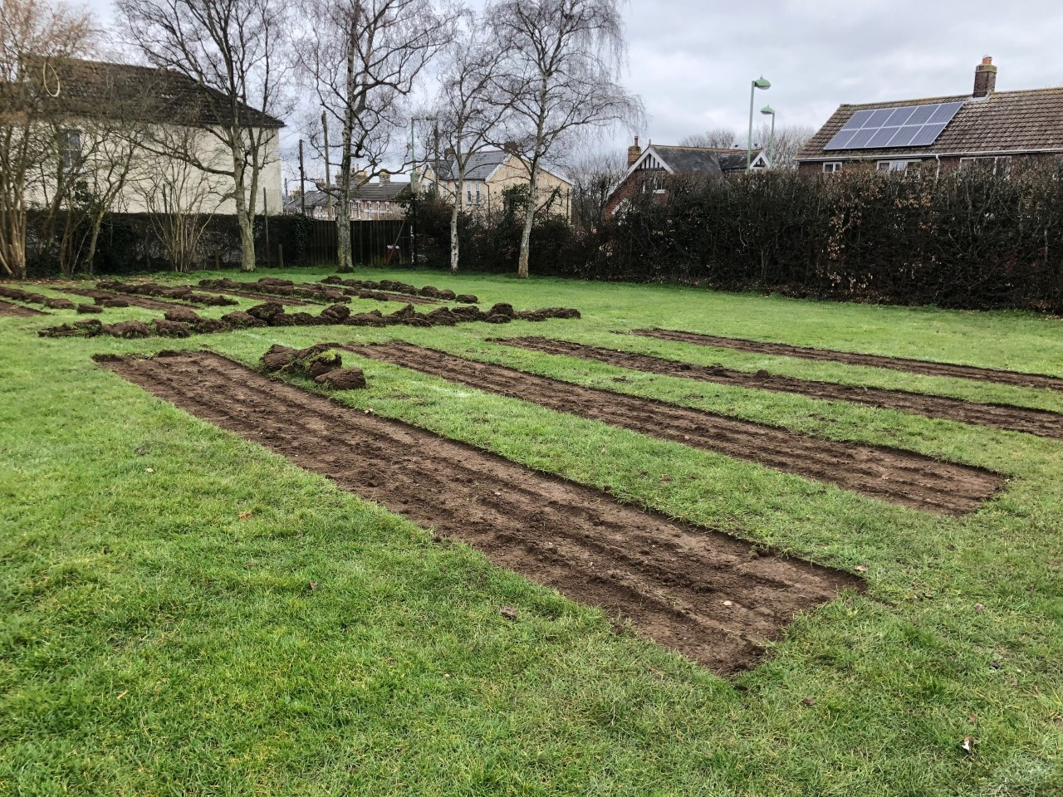

**Forest School.**

Our children in Early years and key stage 1 have a new area to work and play. They have a mud kitchen and beds to enjoy digging. We are very grateful to some wonderfully helpful parents, husbands and grandmas for their help in achieving this space. The children are loving going outside and digging and creating their wonderful potions etc. As the children said, ‘This is proper mud!!’

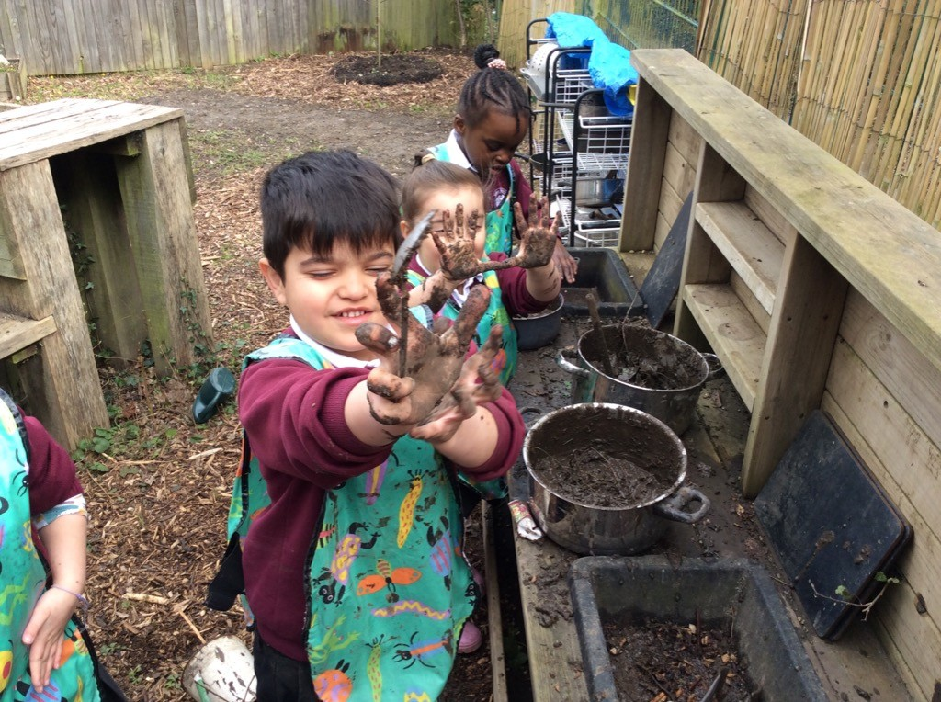

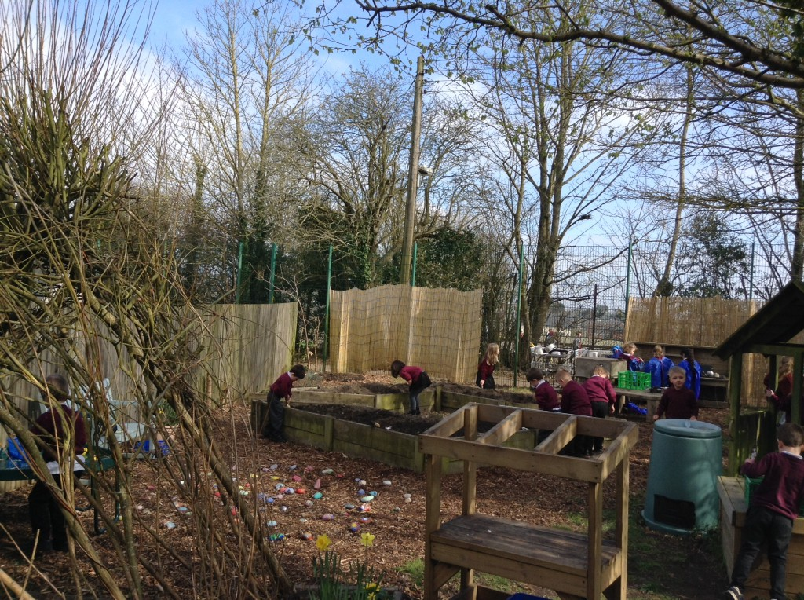

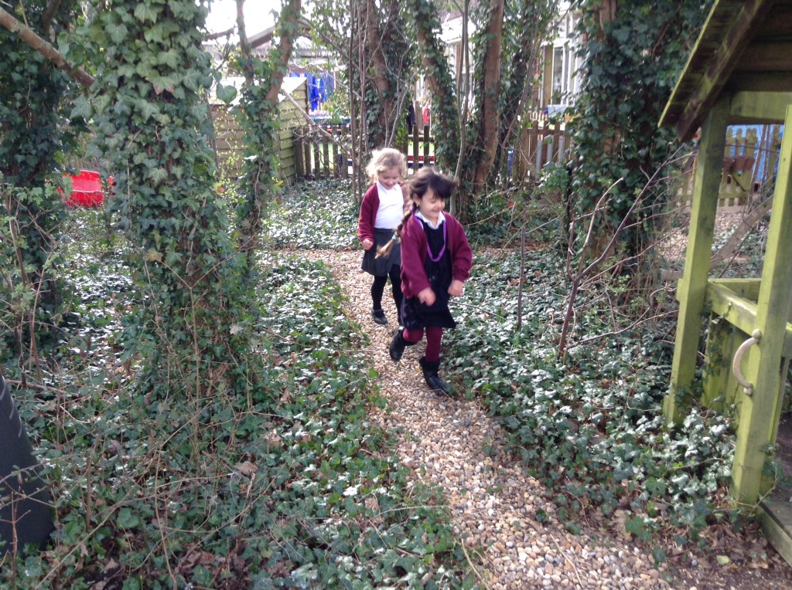

**‘A Time to Plant’.**

Our National Day of Reflection this week was around the theme of ‘A Time to Plant’ from Ecclesiastes.

‘A Time to Keep’ our thanks and memories of the bravery and courage from the past year.

We thought about the things we were grateful and thankful for from the past year. The children were thankful for doctors and nurses, people who work in supermarkets, teachers and school staff for their help with their learning and for zoom so they could still see their friends.

‘A Time to Mourn’.

We thought about the things that had made us sad this year. These things included some family loss, not seeing their grandmas and grandads, not being able to play with their friends and not being able to come to school.

‘A Time to Plant’

We thought about the things we are looking forward to doing and we all planted a sunflower which we will put out in our school grounds for us all to enjoy. As the flower will blossom so will our year with hope for future events we are looking forward to.

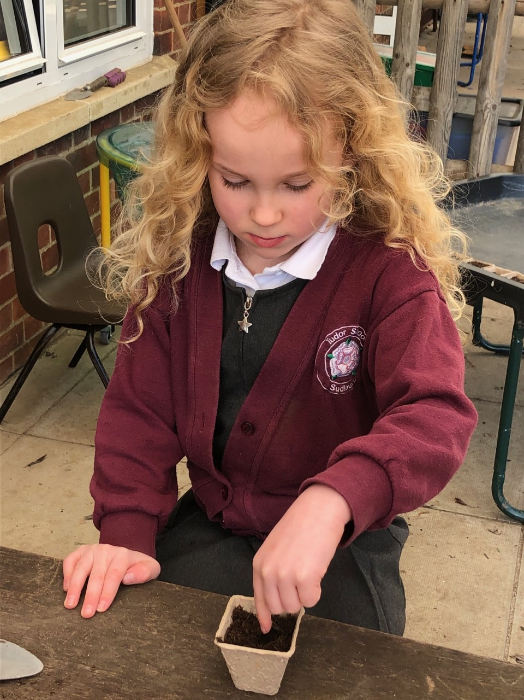

**Rainbows of Hope.**

Our ‘Rainbow’ group continues to meet weekly for their ‘working lunch’ with Mrs Campbell. We have a socially distant meeting and our main purpose is to bring some light, hope and joy to school during this time. Our main task since coming back from Lockdown has been to brighten up our path into school. We have cleared any rubbish and have asked all the classes to paint some pictures of daffodils. We shared a YouTube link about painting a daffodil accurately and after looking very closely at the petals and the way they stand.

Here are some which are wonderfully colourful and cheerful.

