**Tudor CE Primary School**

**Hollow trees visit**

The children in Early Years enjoyed a trip to Hollow Trees Farm shop. This is an annual event for us here at Tudor.

We love taking the children and their parents too.

The children planted pea seeds, picked rhubarb ready for crumble making, planted shallots and learnt about a combine harvester. They had a great ride on a tractor and trailer and saw lots of blossoming fruit trees in the orchard. They fed some animals such as turkeys, donkeys, goats, cows and lambs. They learnt how to make butter and grind corn for flour also.

What a wonderful day they had!

Here are just a few highlights!

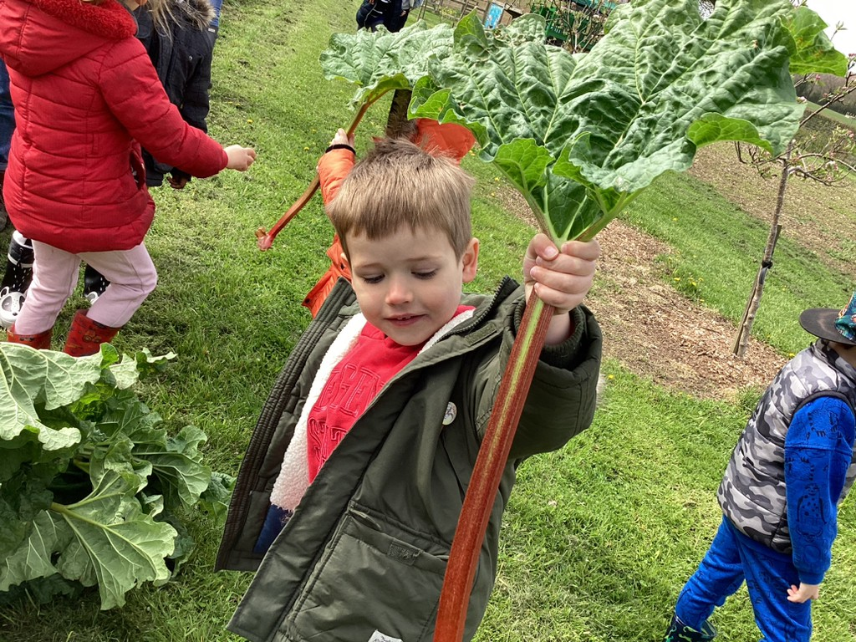

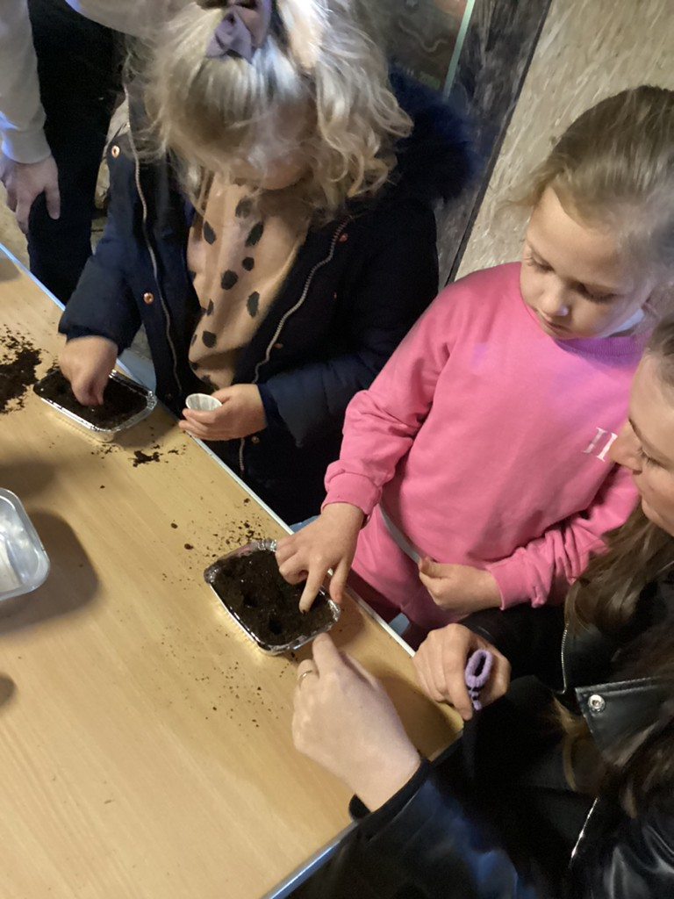

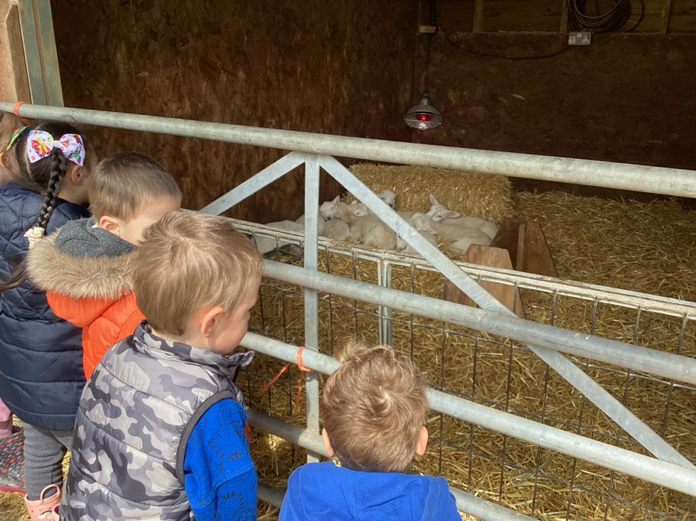

The children followed up the day by making rhubarb crumble the following day in school and enjoying it with some clotted cream! It was delicious – I was lucky enough to be given one!

**Tennis coaching**

Our summer season of sport has started and we are all enjoying using our new tennis courts very much.

We have a tennis coach on a Friday and different classes have lessons with her each week.

We are all incredibly grateful to all our wonderful families for their support with raising the money for these courts and very proud of our children for doing such an amazing job!

Now we can enjoy tennis!

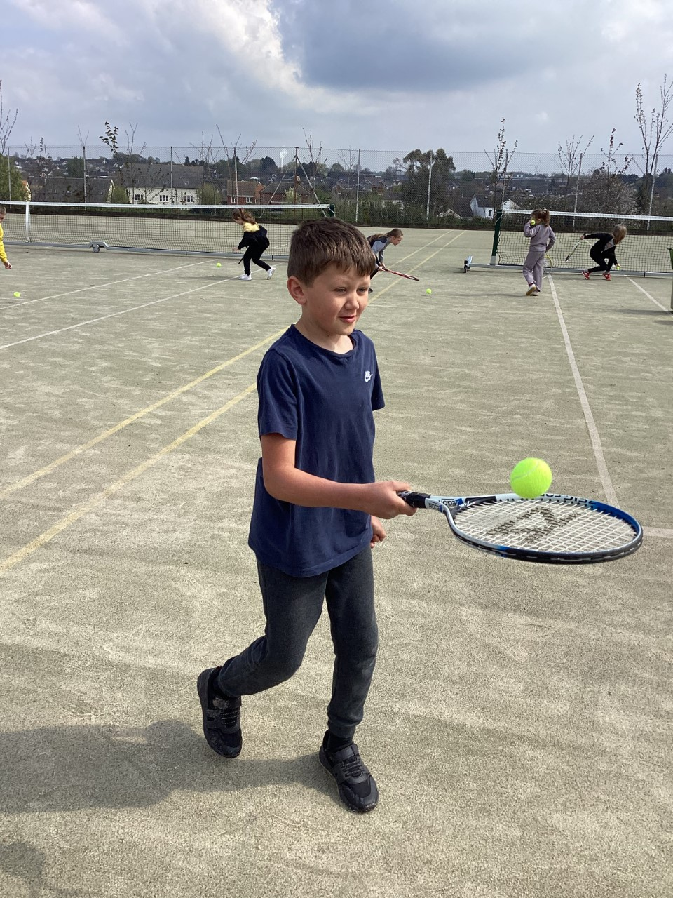

You may even see some of us at Wimbledon in years to come!



**‘Life in all its fullness’**

**Website Article Summer 2023**

**Traditional Scones and Afternoon Tea**

What is a summer without an afternoon tea?

The children in year 5 have enjoyed some weekly baking sessions with myself. We have made scones, washed up, cleared up and the laid our table to enjoy an afternoon tea together. We have discovered some excellent chef’s and the scones of course have been delicious!

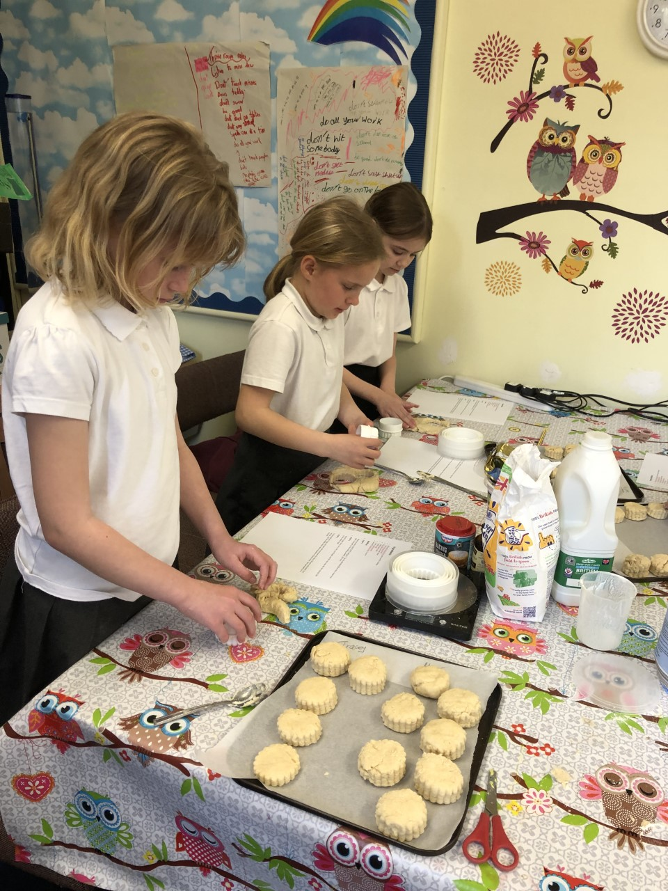

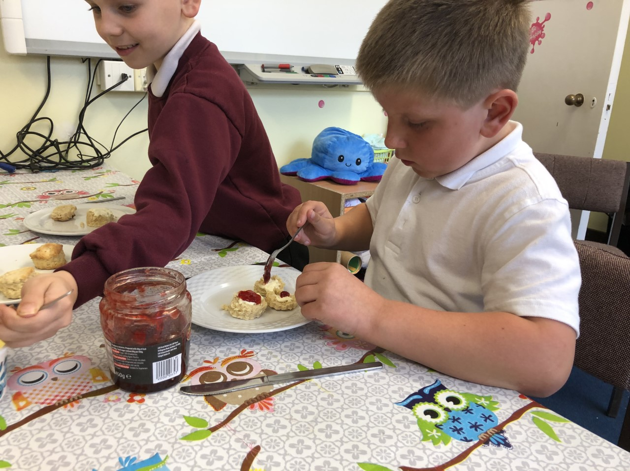

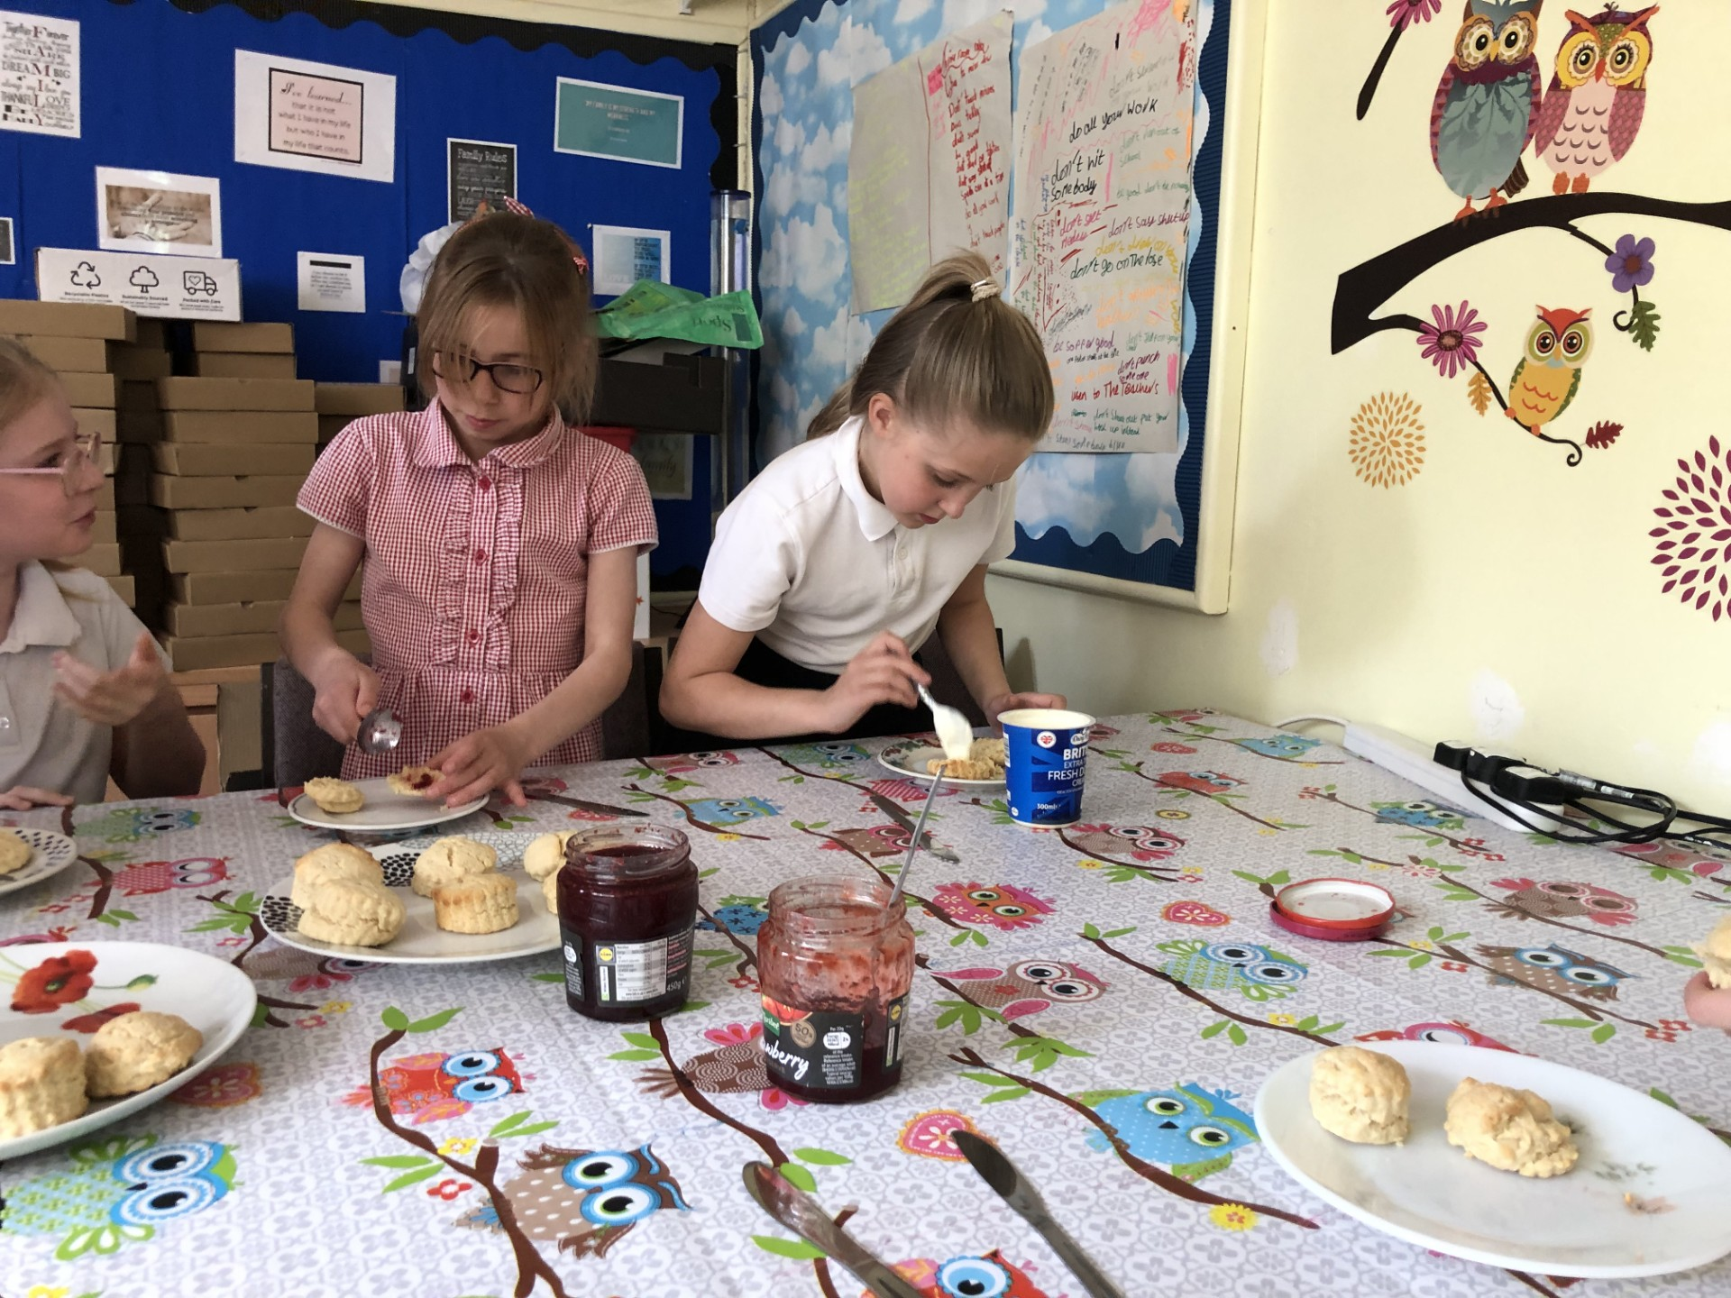

**Friends of Tudor.**

This is our new pond area kindly given a new lease of life by our wonderful Friends of Tudor group.

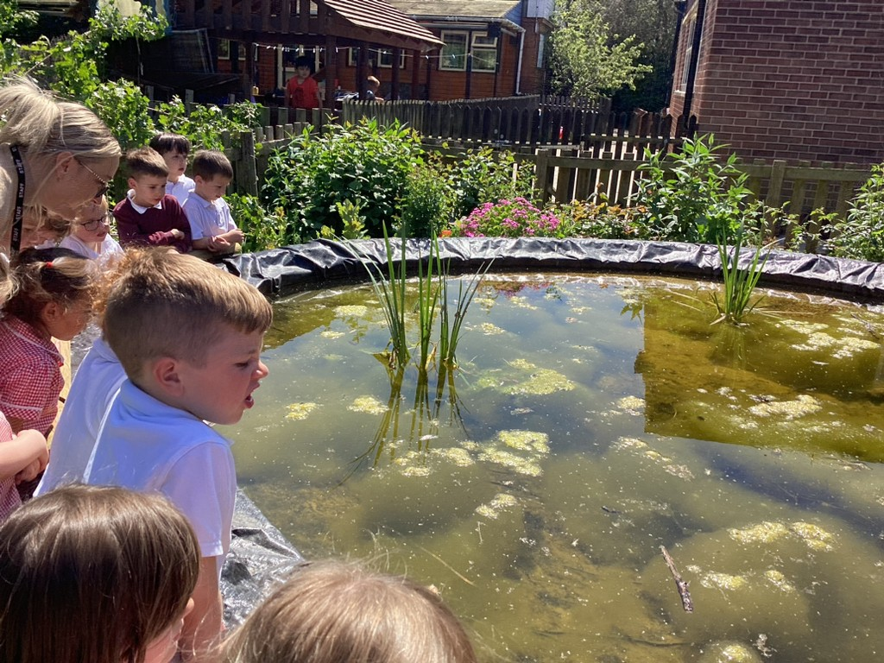

The children can see tadpoles and newts currently and are waiting patiently to see the frogs!

Many thanks to our Friends group!

**Allotments**

We are continuing with our allotments again this year. Year 3 and 4 are working with the country trust and are in charge of the growing.

They have weeded, dug over new beds, and started a bug hotel. The plants they had planted before are all growing despite the birds finding some of them rather tasty! They are growing strawberries, marigolds, squash, onions and others too.

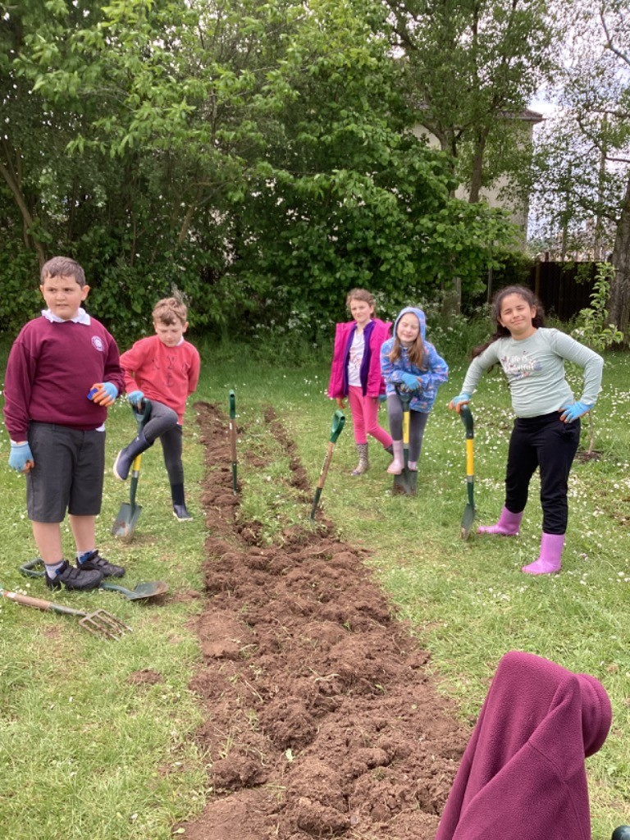

Key stage1 children have also planted potatoes!

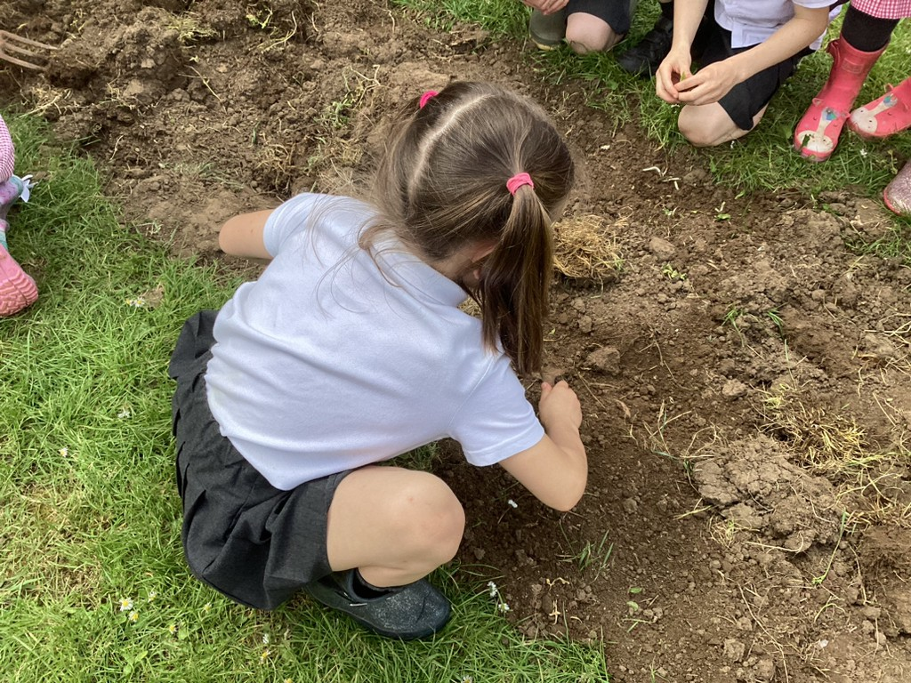

The children will make food with the vegetables and fruits and will hold a farmers market later on this term. We have some really talented gardeners among us!

**Coronation Day**

We celebrated the Coronation of King Charles ii in true Tudor style.

The Rainbow of Hope group decided on our theme and invited all the children and staff to come to school dressed as a king or a queen. We had a party lunch for everyone at lunchtime.

We had formal photos taken of everyone and everyone looked very regal! The children enjoyed listening to Zadok the Priest and acting out coronations in our Early Years class.

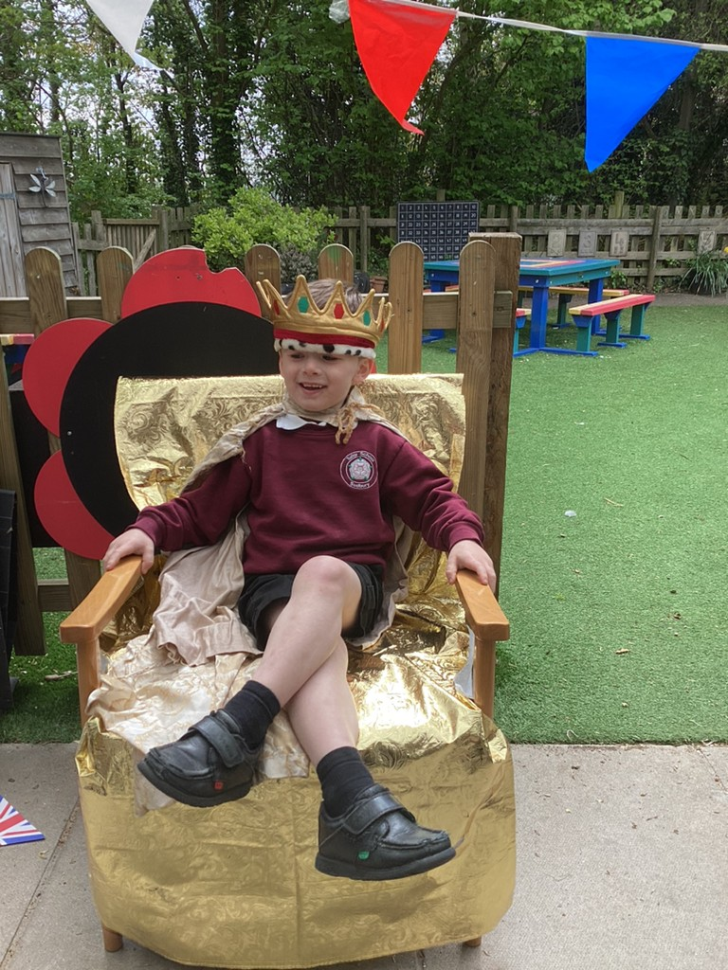

Every child made a crown design that was proudly displayed throughout the school.

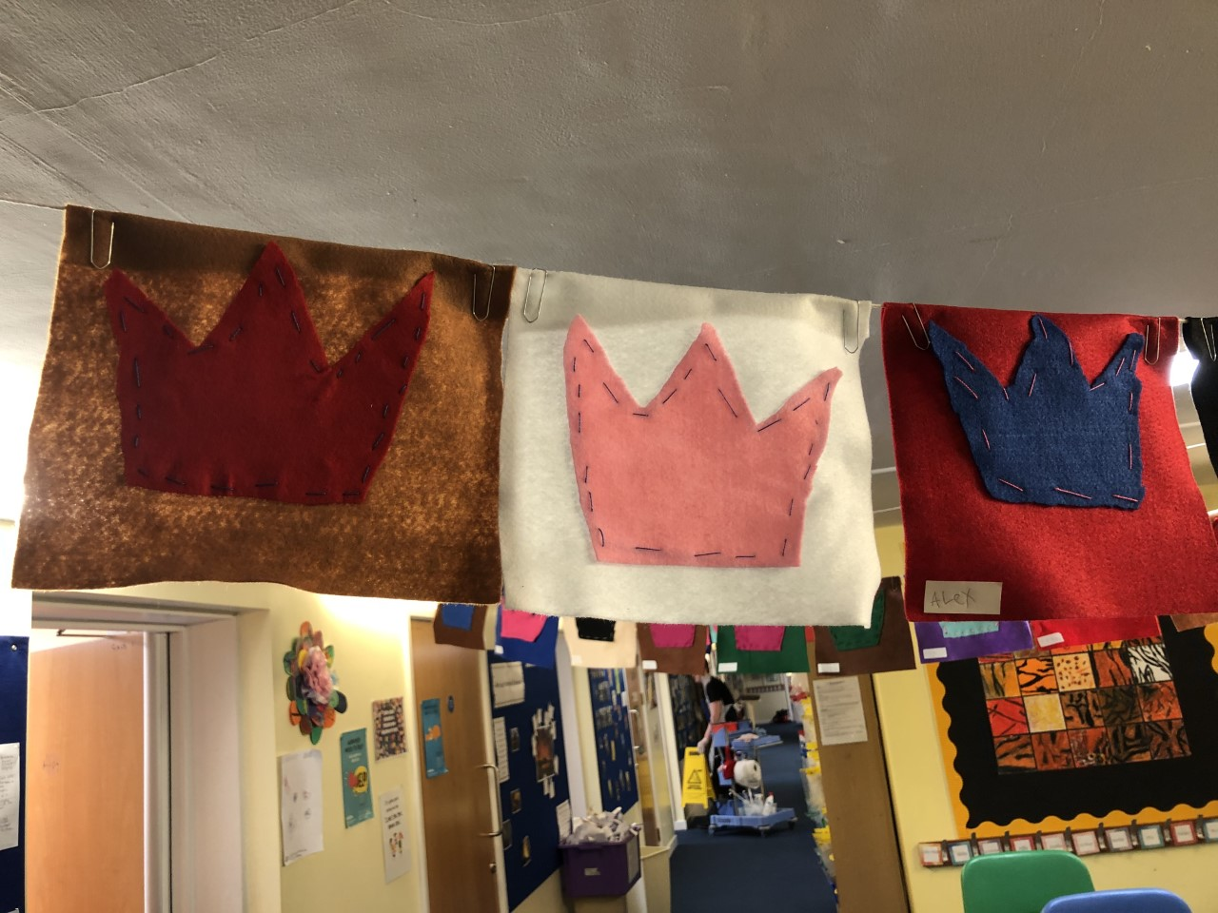

The children also took home a commemorative coin for the coronation. It was such a memorable and happy event and one we hope the children will remember fondly!

**Sports day**

Sports day came slightly earlier this year at Tudor and we had a fun day on Wednesday 7th June.

We had races on the field all day and the children also joined in with other sporting events when they weren’t racing, not forgetting of course the pre-schoolers race, the mum’s race and the dad’s race.

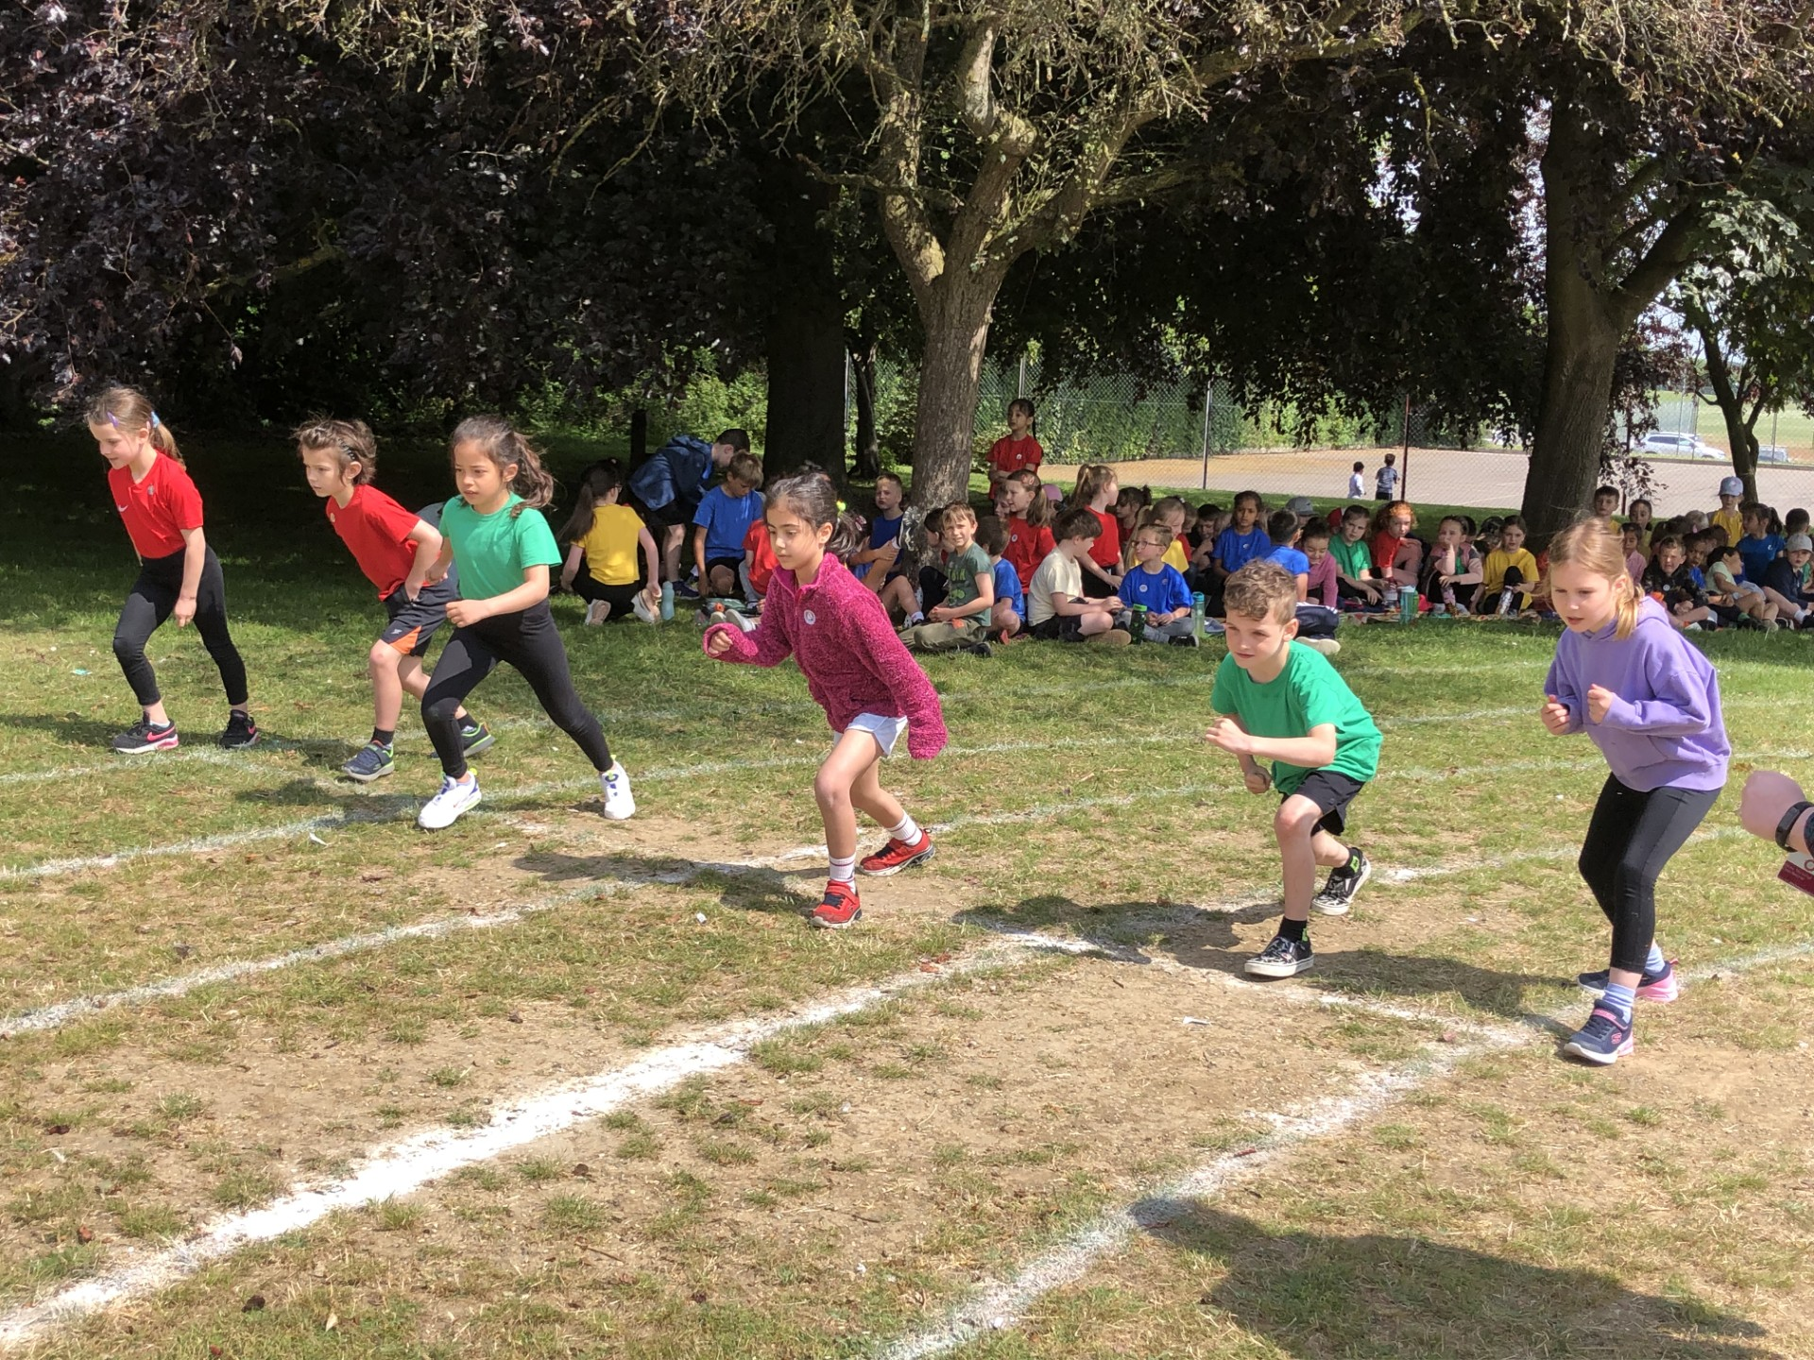

The children competed in their houses and the winning house will be presented with our House Cup the end of the summer term.

It is being fiercely fought currently!

