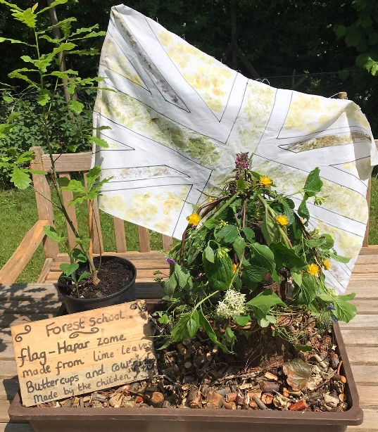
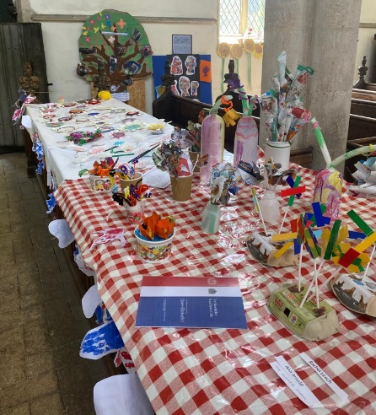
Wetheringsett’s Jubilee celebrations
The children had so much fun using recycled materials to create a beautiful flower display for the celebration at the church. The children also used leaves to make a flag and crown at forest schools.
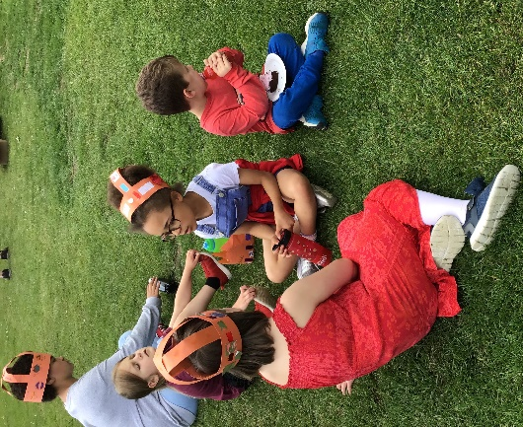
The children had great fun making flags, crowns and cakes for the Jubilee. The children all entered a home baking competition which the teachers enjoyed judging! Congratulations Toby Wright for winning 1st place. The cakes were then sold at our afternoon tea event. Parents enjoyed eating cake and watching the children in a range of sporting activities.
