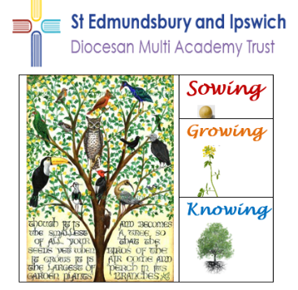

Wetheringsett Church of England Primary School
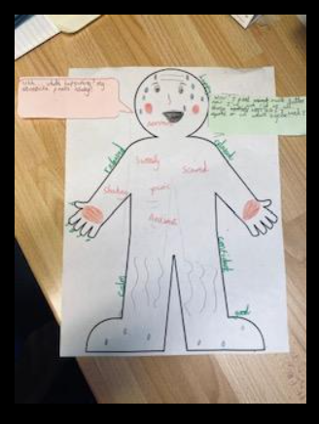

At Wetheringsett, the children studied online safety during Safer Internet Day. Sycamore Class illustrated how they felt when they were worried about an issue online and their feelings after telling an adult about it. This proved how important it is to share worries.

Lime Class made these amazing hand puppets during Design Technology Day. They showed how they could create individual designs, select materials and sew.
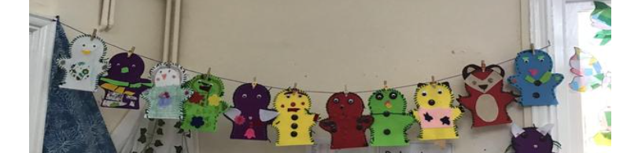
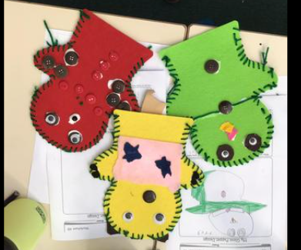
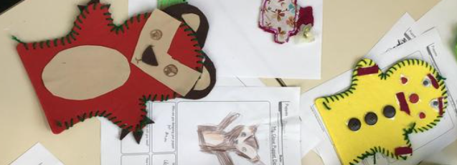

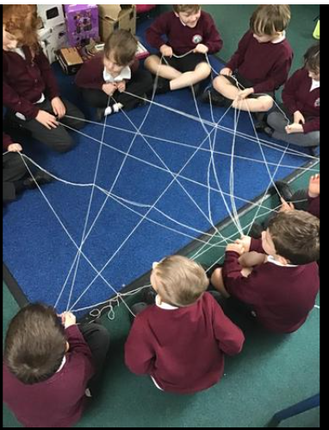
During World Thinking Day, Brownies and Girl Scouts came to school wearing their uniforms and explained some of the activities they have been doing to make a difference to the lives of others. All three classes took part in activities to think about diversity in the world.
